COLLEGE OF NON-CONVENTIONAL VOCATIONAL COURSES FOR WOMEN
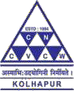
(CNCVCW), CSIBER. KOLHAPUR

A PROJECT REPORT ON

“STORYBOARDING”

SUBMITED TO CNCVCW AFFLIATED TO
SHIVAJI UNIVERSITY KOLHAPUR

IN PARTIAL FULFILLMENT OF REQUIREMENT FOR THE DEGREE OF

BACHELOR OF MULTIMEDIA

SUBMITTED BY

SHUBHANGI R. AVAGHADE

UNDER THE GUIDANCE OF
MR.RAGHUNATH TOPKAR
ASSISTANT PROFESSOR
DEPARTMENT OF MULTIMEDIA 2020-2021

DECLARATION

I hereby declare that, the project work entitled “STORYBOARDING” is my original work. To the best of my knowledge and belief it contains no material previously published either written by another person or material which to a substantial extent has been accepted for the award of any other degree or diploma of the university or other institute of higher learning. Except where due to acknowledgement has been made in the text.

NAME: MISS. SHUBHANGI R. AVAGHADE. ROLL NO. : 01

DATE : 10 / 07 /2021
COLLEGE OF NON-CONVENTIONAL VOCATIONAL COURSES FOR WOMEN (CNCVCW)
CSIBER, KOLHAPUR.

CERTIFICATE

This is to certify that, SHUBHANGI R. AVAGHADE Of Bachelor of Multimedia (B.M.M.) III has satisfactorily completed the project entitled “STORYBOARDING” in partial fulfillment of Bachelor Degree in Multimedia affiliated to Shivaji University, Kolhapur, for the academic year 2020-2021.

Mr. RAGUNATH TOPKAR
(Project Guide)

Forwarded Through: Dr. A. R. Kulkarni

(M.Sc., PhD, MMEI, RQP, LEAD AUDITOR (EMS))

(Principal)

EXTERNAL EXAMINER

ACKNOWLEDGMENT

I have great pleasure in the submission of this project entitled “STORYBOARDING” in partial fulfillment of Bachelors of Multimedia (B.M.M.) program.
While submitting this project report, I take this opportunity to thank those directly and indirectly related to project work. Without their active co-operation and guidance, it would have been extremely difficult to complete this task in time.
As the outset, I keep in record my deep sense of gratitude towards my project guide MR. RAGUNATH TOPKAR who guided me, right from initial stage of project and offered me several valuable suggestions for developing this project in a systematic and presentable manner.
I am also thankful to our Faculty Members, Dr.A.R. Kulkarni, Principal and Dr. A.D. Shinde, Secretary and Managing Trustee for their support throughout my project work.

DATE:

PLACE: CNCVCW, Kolhapur Shubhangi R. Avaghade

ABSTRACT

The project titled “storyboarding” is all about creating a best storyboard. Before and during production, storyboards bring previously abstract images and intentions into physical reality, creating a common visual ground for your cast and crew to inhabit.
In this project I have added the importance of storyboard artist in the production team , types of storyboarding, the basic components of storyboarding and the basic steps using for it. Also there is main importance of design com and colors.
In this project I have done a storyboard . For designing this storyboard I have used traditional method of storyboarding which is also known as frame by frame storyboarding. In this type of storyboarding we have to mention the angle of a storyboard panel, sound which is used , and the description of the shot, and the time duration for the shot. Also for creating the storyboard I used wide screen panel .

INDEX

CHAPTER  NO. | NAME | PAGE  NO.
1. | INTRODUCTION OF STORYBOARDING | 7 - 9
2. | HISTORY OF STORYBOARDING | 10 - 14
3. | THE STORYBOARD ARTIST IS A PART OF PRODUCTION TEAM | 15 - 17
4. | BASIC COMPONENTS AND PRINCIPLES OF THE STORYBOARD | 18 - 23
5. | TYPES OF THE STORYBOARD | 24 - 30
6. | BASIC STEPS OF A STORYBOARD | 31 - 33
7. | DESIGN, COMPOSITION AND COLOUR | 34 - 40
8. | EXAMPLE OF STORYBOARD (OWN) | 41 - 57
9. | CONCLUSION | 58 - 59
10. | REFERENCES | 60 - 61

CHAPTER – I
INTRODUCTION OF
STORYBOARDING

INTRODUCTION OF STORYBOARDING

Storyboards have been used in the film industry since the 1930s when Disney storyboarded The Three Little Pigs. Since then storyboarding is used not only for full-length films but also for pitching advertisements, short films, animations, stage production and even photography ideas.
Storyboarding plays a very important role in the planning, production and post production of any sort of multimedia project. Storyboards help movie-makers get their ideas down on paper in a very visual and easy to understand way; this helps the director communicate his plans with actors, cameramen, lighting crew and clients and producers.
• a visual script • step-by-step production guideline • roadmap of the project
• series of images that simply/briefly illustrate the film's key scenes and events.
Storyboarding can help you develop your ideas and think of things you might not have thought of before.
If you can get anything down on paper...Excellent! But practicing our drawing and getting better at creating detailed storyboards is a very useful skill to have. You don't need to be directing films in Hollywood to put storyboarding skills to good use.
A few ways that storyboarding skills might help you in the future: • Storyboarding develops your general communication skills • Been able to read storyboards will help you if you ever need to hire someone to create something for you • Been able to draw storyboards may help you in your workplace, university or school environment if you need to propose a plan or strategy to a group of people • Learning how to plan and think ahead will help you personally and professional.
To be a storyboard artist is to illustrate the individual frames that make up the shots in a shooting script for animated feature ﬁlms, industrial ﬁlms or multimedia projects, and educational ﬁlms. All these genres use storyboards in one form or another. You are part of the preproduction team and will work with producers, production designers, directors of photography and the special effects teams, but most of your storyboard work will be done with the director, whose vision of the project will guide the entire production team.
The Art of the Storyboard II seeks to help you in the following ways:
● To summarize the history and development of the storyboard and to clarify its adaptation and function as a viable visual tool for the creative team that produces live-action feature length ﬁlms, animation ﬁlms, cartoons, multimedia/industrial films, videos and documentaries.
● To provide basic exercises and illustrations to help you develop the drawing, drafting and design skills essential to creating an artist’s style that will satisfy the needs of the director.
● To increase the appreciation of the storyboard as a preproduction tool for producers, directors, cinematographers, art directors, etc. in any media who are not familiar with its processes and purposes.
● To help the student of storyboarding or films techniques whose time or funds restrict participation in organized classes.
● to serve as a standard text or a supplementary text for established art or films studies at a secondary or college level or in films schools. Stills from historically important ﬁlms – from silent to sound – will be used throughout the text to illustrate their design qualities and “stopped action.” These are actually parts of a storyboard, called “shots” or “stills” from key frames. Each of the chosen renderings, from almost 200 entertainment projects, will serve three basic functions:
● To place the films in its historical context in the evolution of films styles, particularly those nominated for or awarded Academy Awards for Best Picture, Best Cinematography, Best Production Design/Art Direction or Best Special Effects.
● To clarify each films unique compositional qualities, such as its use of framing in the context of reproducing a three-dimensional reality on the screen.
● To delineate the dynamic placement of ﬁ gures, use of camera angles (the point of view of a character often dictates the camera angle used), and the director of photography’s or cinematographer’s “painting with light” and the striking visuals created by light and shade (chiaroscuro). The stills or shots that have been analyzed and interpreted serve as illustrated frames that make up the visual narrative that is the sequential action of the storyboard. These key frames – when ﬁlmed as individual shots then projected on a screen at
Xii Introduction
30 frames per second – induce a persistence of vision on the human retina, thus creating a “cinematic motion” in the viewer’s perception.
The basic drawing techniques illustrated in this book will be applicable to any creative work the storyboard artist is assigned to do in the world of feature ﬁlms, whether it involves the use of computer generated images, special effects and compositing or not.

CHAPTER – II
HISTORY OF
STORYBOARDING

HISTORY OF STORYBOARDING
The ﬁ lm industry’s current use of storyboards as a preproduction, pre-visualization tool owes its humble beginnings to the original Sunday comics. Pioneers like Winsor McKay, whose Gertie the Dinosaur (see Figure 1-1) and animation of the Sinking of the Lusitania (1915) established him as the true originator of the animated cartoon as an art form. He paved the way for Disney and others.
The concept of telling a story through a series of sequential drawings actually goes back to Egyptian hieroglyphics, even back to the cave men’s drawings of stampeding cattle. The Bayeux Tapestries (1050), woven on linen and depicting with brutal narrative action William the Conqueror’s invasion of England, is still awe-inspiring and has its own claims to being some of our ﬁ rst “storyboards.”
Charles Solomon’s History of Animation begins much later with the traveling magic lantern shows of the 1600s and takes readers from the optical illusion of Phantasmagoria in the 1800s to the contemporary animated cartoon: from Felix the Cat and Mickey Mouse in the 1920s up to Jurassic Park and The Lion King in the 1990s. Lately, we’ve had the brilliant 3D effects of The Incredible (2004), Shrek (2001) and Madagascar (2005).
George Méliès, the French conjurer, illusionist, theatrical set designer and magician whose ﬁlms projected optical tricks and fantasies. His Trip to the Moon (1902), with its stunning imagery of a rocket going “splat!” in the eye of the moon, is still used for documentaries and commercials. His other ﬁlms include Cinderella (1899) and Joan of Arc (1902), and generation after generation continues to be fascinated with Méliès’ inventive films spectaculars. Other artists who paved the way for animation were Felix Messmer, whose mischievous Felix the Cat (1914) became the world’s most popular cartoon character, and Max Fleischer, who is best known for his still popular Betty Boop character.
Let’s not forget Ub Iwerks, credited by many as being the original concept artist for Mickey Mouse, who bore a striking resemblance to Ub’s Oswald Rabbit. 1929 was the beginning of the so-called “Disney Era,” which reigned through the early 40s, when the entire world fell in love with Mickey Mouse (now just a corporate icon), Donald Duck, Pluto and Snow White and the Seven Dwarfs (1938), the ﬁrst full-length cartoon, brilliantly Technicolored and a giant money maker for Walt Disney.

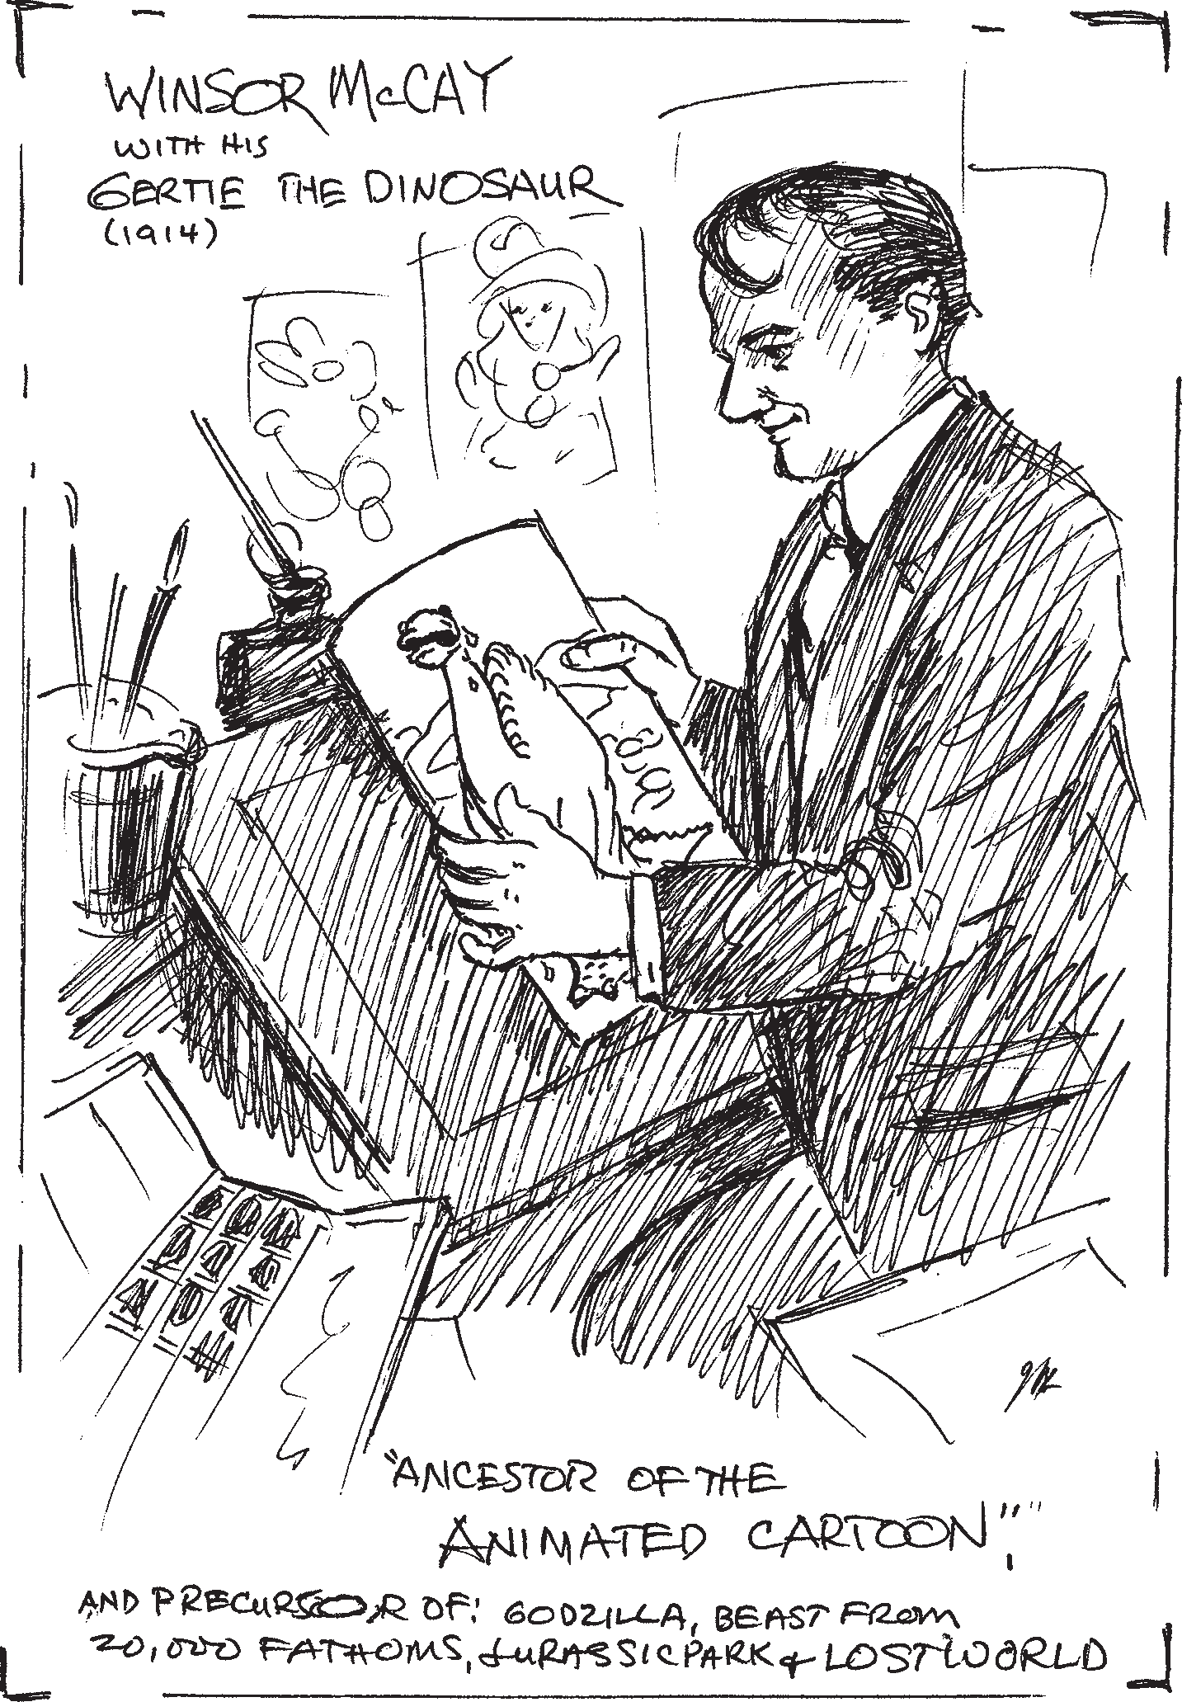

Hart’s sketch of Winsor McKay with Gertie the Dinosaur, the ancestor of the animated cartoon. McKay’s hand-drawn style is still influencing Disney’s animators.

Working from the original story idea, storyboards enable the entire production team to organize all the complicated action depicted in the script, whether being rendered for live action films, animation, or commercials. They will illustrate what action each lifted shot contains. By doing one’s own storyboards carefully and thoroughly, you know exactly what is going to be done before the actual filming begins – every shot and every camera angle, along with what lighting, sets and props will be used.
In a 1998 interview in VISFX with Editor Bruce Stockler, Ray Harryhausen responded to a question on how he learned about storyboarding: “I learned storyboarding from Willis O’Brien. He storyboarded everything. He started a film before KING KONG called creation (1931) at RKO. When Merian Cooper took over, he put the gorilla in it, and they added parts of; lost world and they built that up to be King Kong. It was a great experience to work with him. He would make 20 or 30 drawings a day, little ones, about the size of the [indicating a napkin] . . . then he would paste them up and write captions underneath and we would do each scene that way. They were all numbered, so you knew when the close-up was coming, the camera angle and the framing, and whether you needed a rear-projector or a split screen or whatever.”

Basically, the same structural techniques were used by Peter Jackson in his 2005 remake of King Kong. The big difference being that Jackson’s compositing frames set-up (putting as many as 20 or more computer generated images together in one shot) were created especially for Kong by his own company, WETA Digital Effects.

Earlier, WETA Digital had composited such elements as real location shots, matte paintings, 3D miniatures and live actors to create his Oscar winning trilogy Lord of the Rings in 2001–2003 (Figure 1-2). Rings were followed by chronicles of Narnia (2005) for Disney. Howard Berger, the head creative designer and supervisor for , relates in the Official Illustrated Movie Companion to chronicles of Narnia, “When I first met [director] Andrew Adamson at his modest office in Burbank, he showed me the presentation room where hundreds of preproduction drawings for the Narnia movie hung. These drawings [storyboards] by the preproduction artists

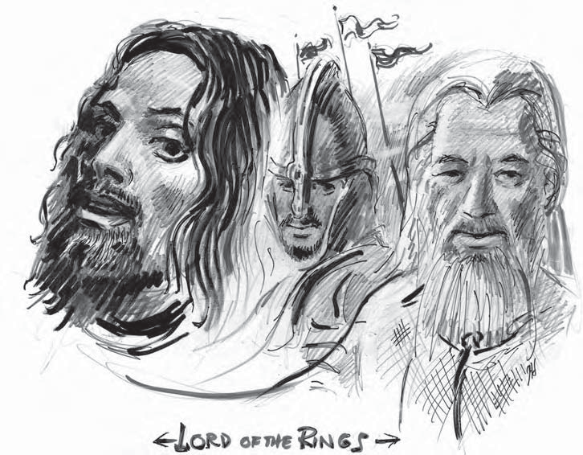

Hart’s composite sketch of the characters from Peter Jackson’s, Lord of the rings trilogy.
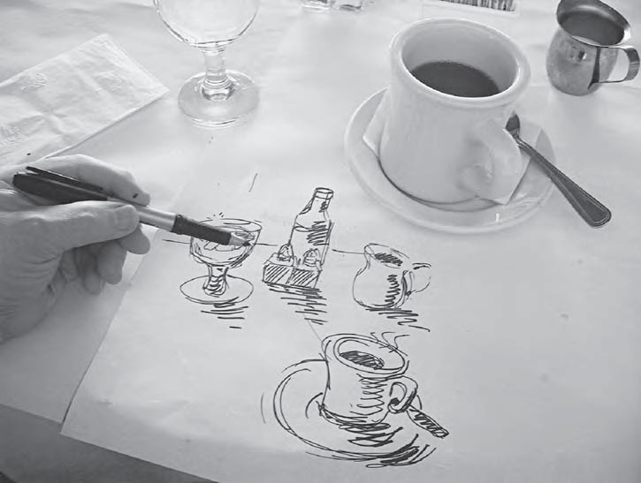

Hart’s example of a quick concept sketch drawn on a paper tablecloth in a restaurant. Notice the use of basic geometric shapes and shading.

\

CHAPTER – III

THE STORYBOARD ARTIST IS

A PART OF PRODUCTION

TEAM

THE STORYBOARD ARTIST IS A PART OF PRODUCTION

TEAM

Beginning with the concept sketches that visualizes a selected scene from a script narrative or making on-the-spot Thumbnail sketches for the preproduction team, the storyboard artists not only impress those involved but also realize that it is a reward- ing creative experience. They note the pleased expressions of the directors and pro- ducers when they see the scene created for them visually as the movie takes shape “before their very eyes.” Now they have actual images that have come alive, spring- ing up from the script’s printed word and translated into reality by the storyboard artist. The art director and the production designer will also relate to the storyboard artists “on demand” output

from the beginning, the evolution of the storyboard is intertwined with the history of 20th century cinema. Some directors like Sergei Eisenstein made simple sketches in the margin of the script (Figure 2-1).

Other directors probably kept them in their heads, like John Ford or Cecil B. DeMille in the silent film period. It’s my guess that if the early master directors didn’t use a storyboard per se; creative visionaries like D. W. Griffith, Eric von Stroheim, Charlie Chaplin and Buster Keaton were very involved in preproduction planning, even if it was simply the basics. For instance, the day and time of specific shoots, which actors were involved, what location, what sets would have to be built, what style costumes would be worn, who would run the cameras, and what scenes were the director and the cameraman going to shoot at what designated time and location?

Some form of preproduction concept sketching is evolved, if only to give the con- struction and technical crews as well as the actors some idea of what the next shot was going to be. It’s unlikely that someone like Griffith, who was shooting 72

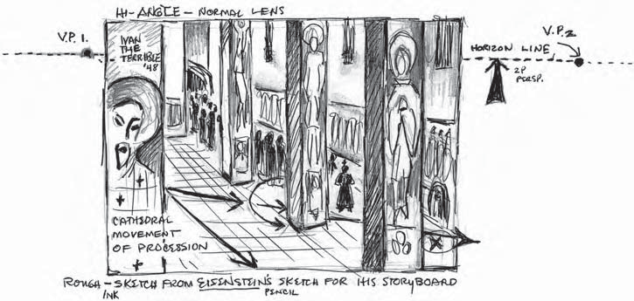9

One- or two-reelers a year, would have had the time to make detailed sketches of every scheduled scene.

Although the storyboard was developed in its more sophisticated form by Disney in the 1930s, Griffith certainly preplanned the setups, set construction, camera move- ments, crane shots and so on. He rehearsed the actors to block each shot. Later, in gone with the wind (1939), David O. Selznick applied many of Disney’s preplan- ning animation techniques to his Civil War epic.
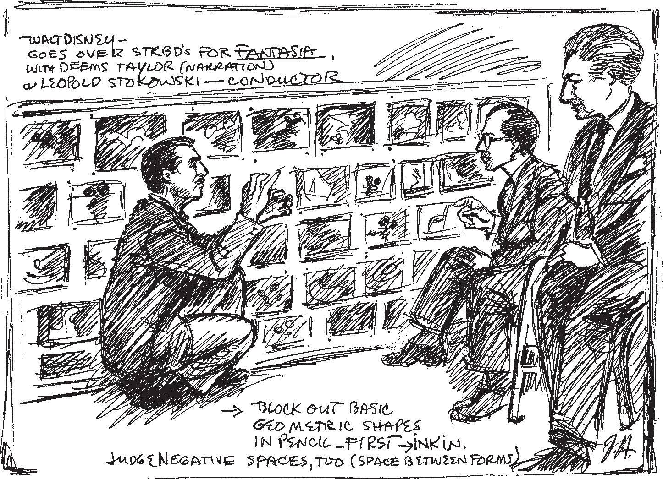

One salient point can be made: Many great producers and directors in the history of the motion picture used some form of preproduction planning. They realized how much time and money could be saved (balancing their budgets) if their preproduction people utilized a carefully laid out storyboard that was the “visual spine” of the screenplay. In other words, they could readily see, by referring to storyboard sketches, who had to spend what and for what purpose.

CHAPTER – IV
BASIC COMPONENTS AND
PRINCIPLES OF THE
STORYBOARD

BASIC COMPONENTS AND PRINCIPLES OF A STORYBOARD

RULE OF THIRDS
Just as a writer has to face a blank page, the artist has to face a blank rectangle on a drawing pad and visualize how to fill that space with the demands of the script. But even before we fill it, the space itself must be in good proportion. Storyboards are drawn in elongated rectangles, to match the aspect ratio of the final image. The aspect ratio of the projected image can range from 1.65: 1 to 2.55: 1 in today’s wide screen formats. These are the same proportions the storyboard artist would use to draw the individual frames. The Greeks called it the. The base of Divine proportion or the golden rectangle the Parthenon is two-thirds the total of the building height, and the pediment triangle is the top one-third (Figure 4-1). This division of thirds is a proportional device utilized in the entire history of art.

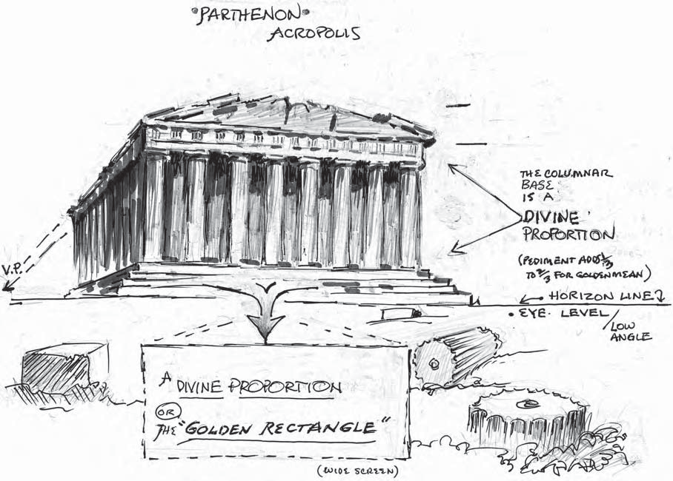

Any professional composition for any frame of film has to follow these historic artistic principles for correct placement of figures, objects or structures drawn within the storyboard frame. The rectangle must first be divided horizontally and vertically into three sections. The points formed by the intersection of the three verticals and the three horizontals become the areas where the center of interest is always placed. This is called the Rule of third.
This rule of thirds is utilized by all professional storyboard artists and production designers. Centering actors or objects in the exact center of any frame is boring, just as a line that intersects the rectangle in the center of the frame is a mistake. A composition is never split evenly in two.

FOREGROUND, MIDDLE GROUND AND BACKGROUND –

You will also maintain the visual interest in your storyboards by keeping in mind each of the basic visual planes that constitute perceived reality – the foreground, the middle ground and the background, often abbreviated as FGD, MGD and BGD .

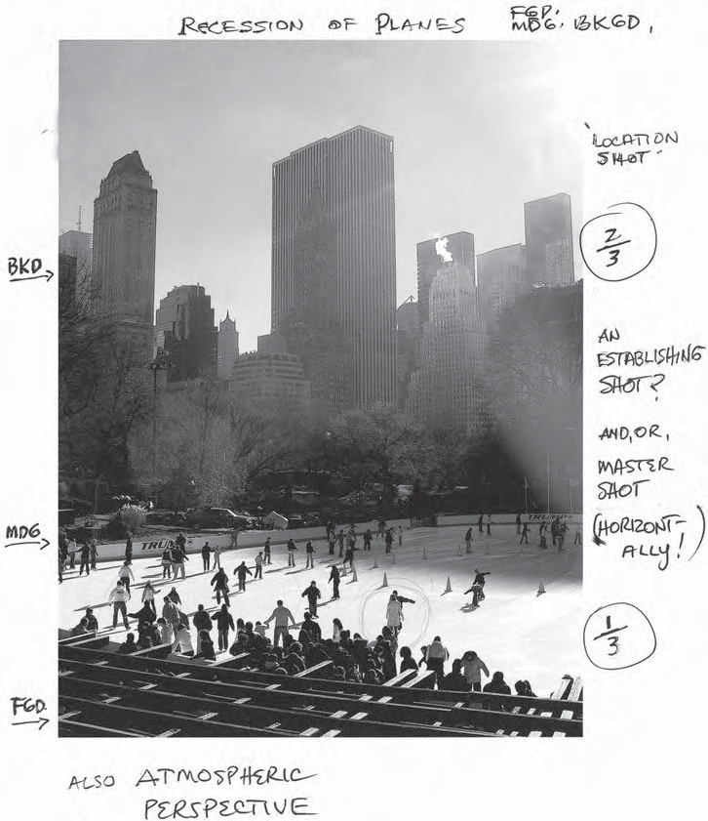

Figure shows a production shot from Memoirs of a Geisha where the geisha is framed by the director of photography and the sound man holding the boom mic. The geisha and her friend are centered but moving off-center to exit at the right of the frame. The camera operator and sound man are in the FGD of this image, while the actresses are in the MGD. The BGD sets the scene for the shot, showing where it takes place. The sketch also demonstrates concentric circles as a framing device. The movie won Academy Awards for Production Design, Costume Design and Cinematography.

DEVELOPING DRAWING SKILLS –

Once again, the concept of the story line and its validity is what counts in conveying the visual interpretation of a written scene broken down into the individual shots. The director has decided which specific shots are needed to interpret the continuity of the screenplay. Our purpose here is to make you familiar with the storyboard process and help you develop your drawing and drafting skills by actually rendering storyboards.

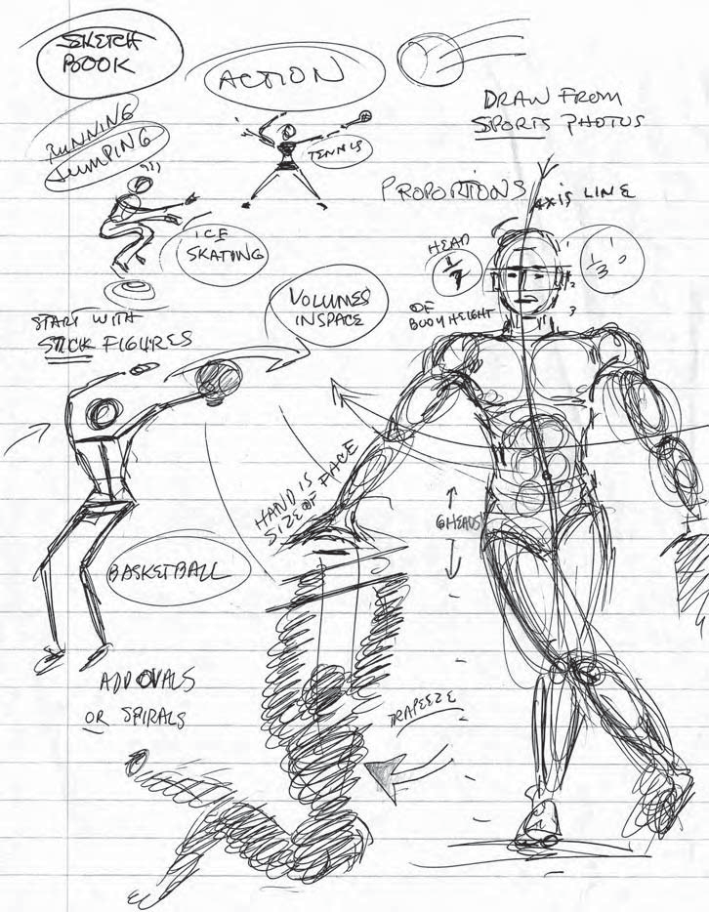

As you make these sketches, keep in mind the proportions of the body. Try to render your sketches in 15 or 20 seconds. This way, even if they are not perfect, you will at least be getting the “gesture” or direction of the body’s movement. Just like a good storyboard, they will have a line of action. They will indicate a line of action through their gestures or body stance. The more you sketch, the more you will be developing your own drawing style.

SHOT ANGLES

- Close-Up (CU): full face shot of actor(s) or up close shot of objects.
- Extreme Close-Up (EXT CU): so close you see only actor’s eyes.
- Establishing Shot (EST): shows the placement of the actor(s) for the audience.
- Long Shot (LS): shows the actor(s) or objects in the distance (background).
- Medium Shot (MS): shows the actor(s) or objects in the MGD.

Over the shoulder (OTS): taken over-the-actors-shoulder; must stay consistent (on same shoulder) for an actor.

Panoramic (Pan): the camera moves horizontally to take in a panoramic scene.

Tracking shot: the camera is mounted on wheels and moves smoothly on a track to capture the movement in the scene. Sometimes a similar “dolly” shot is used, where the camera is pulled or pushed on a cart, like the crab dolly that moves in circular motion.

Zoom shot: the focus goes from wide angle to CU with a zoom lens.

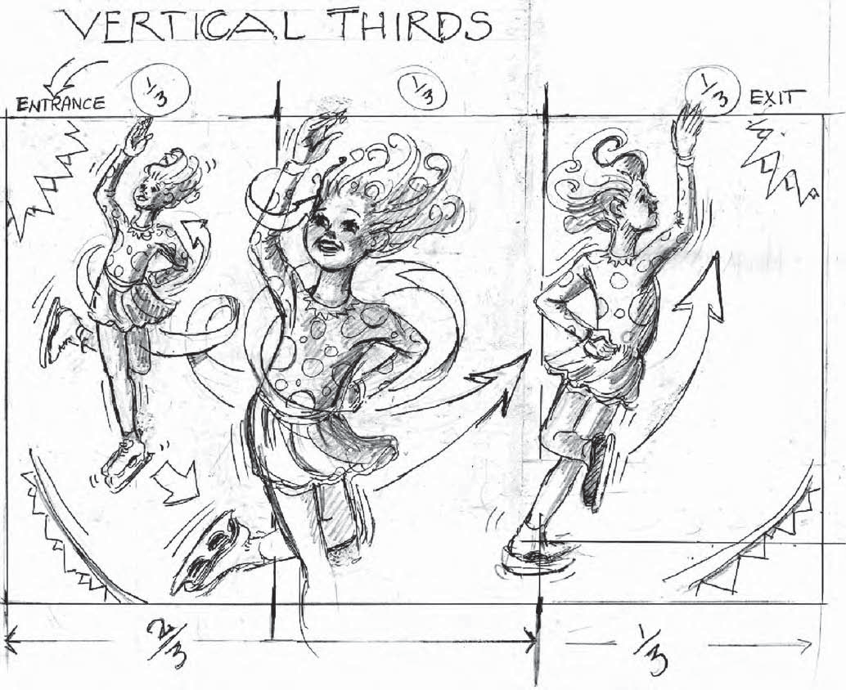

The number of camera angles is virtually unlimited, and camera angles can be used to create unique presentation of the scene, such as the overhead shot . It shows the action as if the camera were positioned on top of the scene looking down. This extremely high angle (attic view) later would be used by Hitchcock in psyco, when Norman stabs the inquisitive detective at the top of the stairs in the Victorian house.

BUILDING THE STORYBOARD

Attention must be paid to motivated light sources. Basic lighting of the main characters or lead actors in a film are lit through the use of the key light (strongest light on the face), fill light used to fill shadows (also called reflective light), and back light or hair light to separate the actor from the background. To quote the famous director Joseph von Sternberg (who directed the early Marlene Dietrich films) “Once you have mastered the key light, everything else falls into place.”
we broke down the scene into the basic shots that it required with these initial rough sketches. He wanted to capture the intense flow of action that would build up to Mary threatening to kill Cardiff. So, keeping the continuity in mind, the power that well-designed frames and the use of fluid, not distracting camera work can bring to a scenario, I started with these thumbnail sketches. They follow the nine shots that we felt this particular page of the script needed to “tell the story” visually.

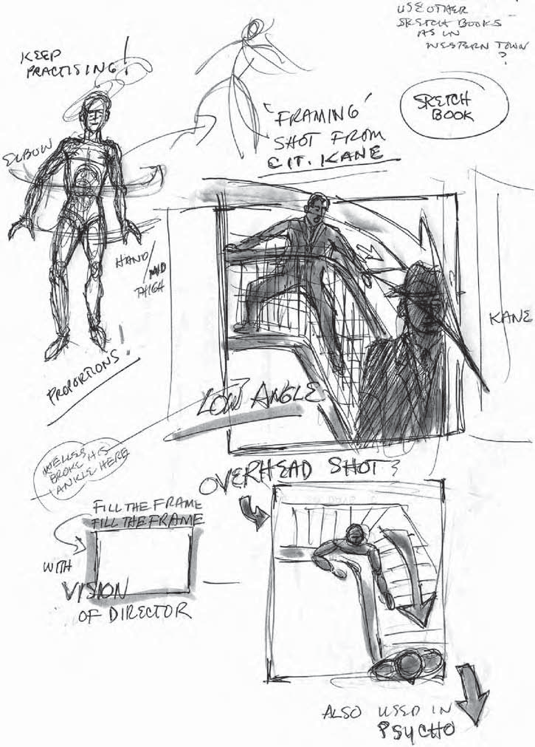

CHAPTER – V
TYPES OF
STORYBOARDING

1. Traditional
Traditional storyboards involve a series of conceptual pencil sketches that help the writer, producer, and director to visualize their initial idea before any filming or animating starts.
These storyboards are still very common in the TV and movie industry today as they allow for changes to be made quickly and inexpensively.
Here’s an example from the animated TV series, Tom & Jerry:

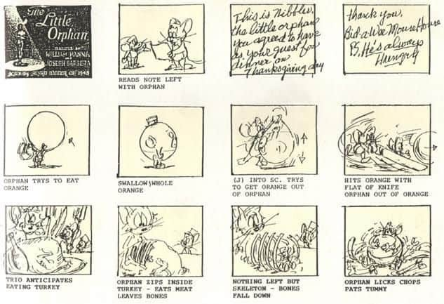

These simple pencil-sketches, paired with written explanations of what the characters will be doing in each scene, help to assist the animation team in following the sequence correctly.

2. Thumbnail
A thumbnail storyboard is usually used by a small team–or even a team of one–who already have a good understanding of how they want to visually portray their idea.
These are very quick and easy to create as no text is required and the sketches don’t need to be particularly detailed.
Here’s an example from the movie, Psycho:

Here’s an example from the movie, Psycho:

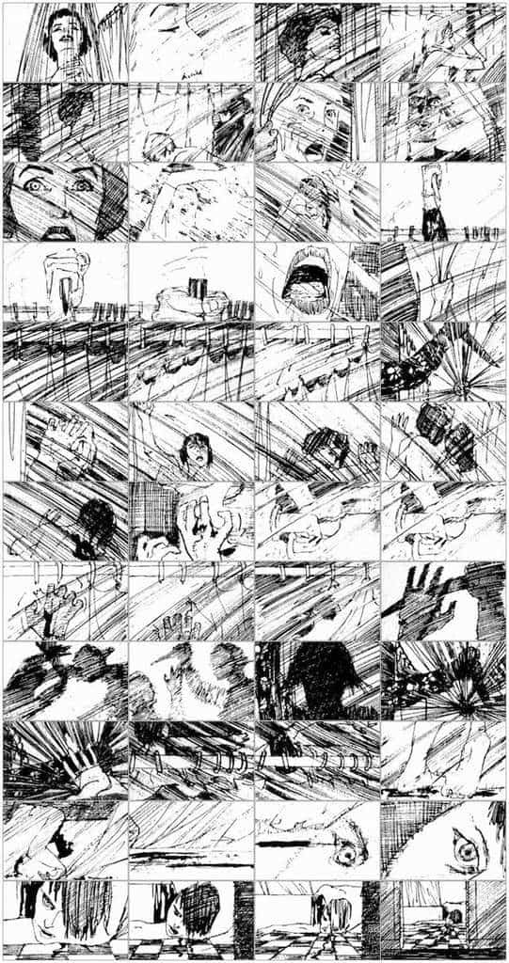

Movie buffs will recognize this instantly as the famous shower scene from Hitchcock’s 1960’s thriller.
Hitchcock was known as an auteur with a very distinct vision when it came to shooting his films, so this storyboard didn’t need to include additional written direction.
Instead, it goes into much more detail visually, showing every single shot exactly as it’s intended to appear in the film.

3. Digital
A digital storyboard is perfect for animated videos because you can use the exact graphics that will be shown in the final video.
This allows everyone involved to get a sneak peek into what the end-product will look like.
We use digital storyboards at Wyzowl because all of our graphics are custom-made for our clients, so it’s important to make sure these are accurate before we start animation.
This ensures that there are less changes later down the line and it also allows our clients to have more of an input into how their video will look.
Here is a storyboard for one of our clients, NLG Health :

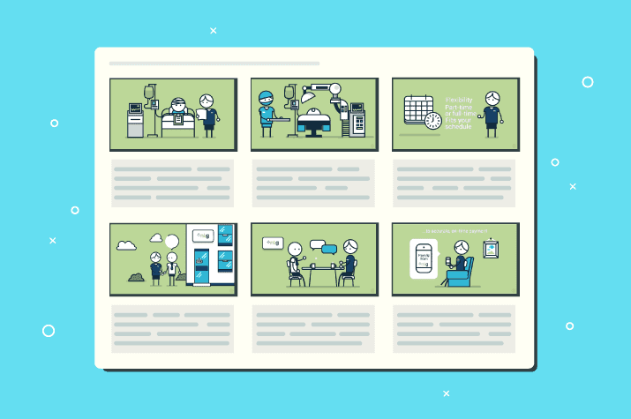

4. Break down your script

If you haven’t already broken your script down into scenes, then start by doing that.
There are many different ways to write scripts, and at Wyzowl we like to use a different box–or ‘scene’–each time the action on screen changes.
Here’s an example:

At this stage, it’s important to plan how many panels your storyboard will have and number each one to ensure there is no confusion in the timeline of your video.

5. Define your visual style

This step is particularly important if you’re working with a client.
Visual style is something that doesn’t necessarily come across through a script, but needs to come across in a storyboard.
Going back to the example of the dancing brunette character, the visual style would determine what clothes she wears and what the scene around her looks like.
If the video is animated, visual style is more important. Just look at the difference between this characters when he is drawn as a flat illustration vs. a 3D model:

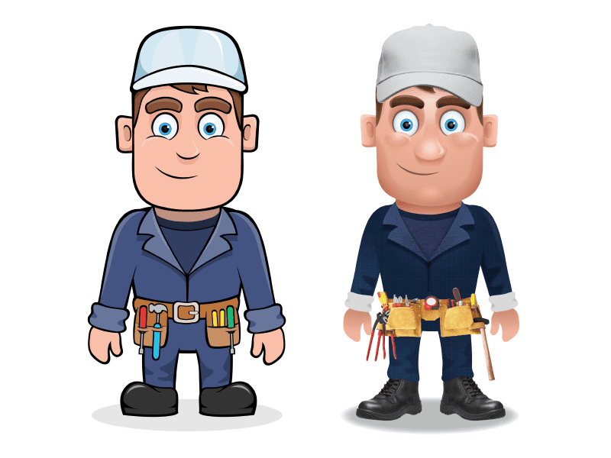

6. Make a list of graphics

After breaking your script down into numbered scenes and determining your visual style, it’s a good idea to create a list of things you need to draw.
Although certainly not essential, this step will help to ensure that nothing is missed from the script.
It also allows you to think about the extra details you want to include in your video before you start recording or animating.

7. Start drawing
This is the fun part!
Choose the type of storyboard that will work best for your project and start drawing. If your video is live-action, then we recommend sketching your storyboard on paper.
If it’s animated then we recommend creating a digital storyboard with software like Adobe Illustrator or an equivalent, such as Inkscape or Gravity.

8. Add text descriptions
Once you’ve completed the visual part of the storyboard, add text to each scene so that everyone who is going to review the storyboard can follow it.
This could be voiceover, character dialogue, or even just a brief description of what’s happening in each scene.

CHAPTER – VI
BASIC STEPS OF A
STORYBOARDING

Basic Steps to a Storyboard -

• Analysis breaking down the story into components
• Evaluation judging and choosing what shots, angles and frame sizes to use for the project
• Synthesis putting the project together

1. Place your shots and scenes in an order that tells a story.
2. Plan your story so that the images and the script can be clearly understood
3. Plan your film in the most interesting and appealing way
4. Plan what happens in each shot & how fast or how slow it happens.
5. Eliminate unnecessary or repetitive shots and add missing shots.
6. Smooth, clear, logical flow from shot to shot and scene to scene.

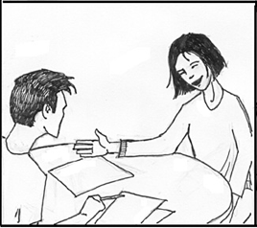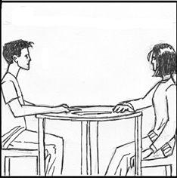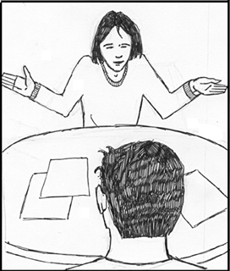

Visual & Written
- Single out the essential details needed to communicate the information in that particular scene.
- two ways
  - Visual
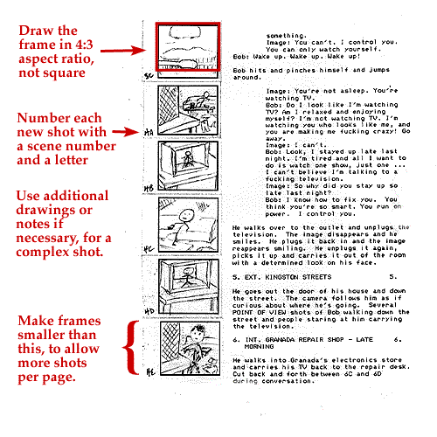
  - written

CHAPTER – VIII
DESIGN, COMPOSITION
AND COLOR

DRAWING HUMANS IN ACTION –
Go to the How-To section of any bookstore and you will find many “how to draw” books written specifically to train burgeoning artists. Books with particular emphasis on drawing the human figure in action will be of immense help for the beginning storyboard artist . For those who will be taking film courses, classes leaning specifically toward the unique art form we know as storyboarding will be taught and mastered.
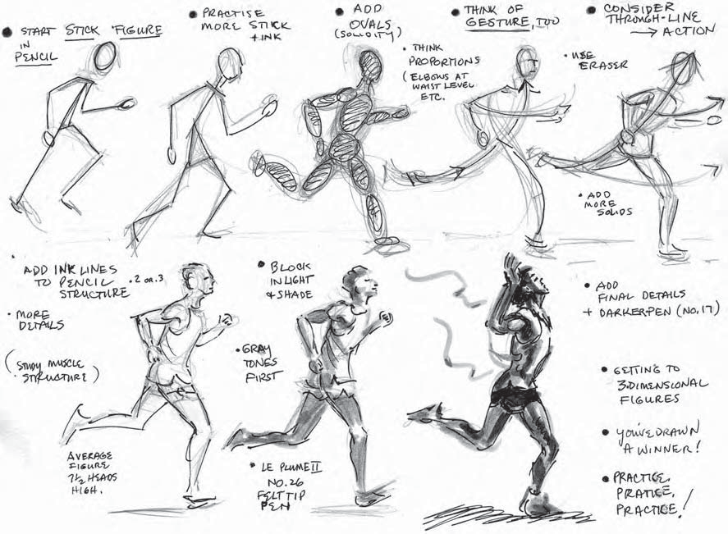
Don’t just sketch the model from straight on. Set the arms, legs, hands, and head in a running position. Then close your left eye and, pretending your right eye is the camera lens, pick up the figure or model and “zoom in” on it from different angles,low angles, high angles, even turn it slowly in front of your “lens.” Sketch the model from these diverse positions. This technique will help you develop a more creative eye for your storyboards. Unusual angles make for more interesting story- boards while you are also improving your drawing skills.

HUMAN PROPORTION –
The human head, as in all of our golden mean proportions is divided into thirds:
O 1/₃ from the chin to the base of the nose
O 1/₃ from the base of the nose to the eyebrows (or ears)
O 1/₃ from the eyebrows to the top of the head

The average male’s body height is 7½ heads tall; the same would apply to the female body, which is usually shorter.
- The halfway point from head to toe would be at the pubic arch.
- The length of the arm to the elbow coincides with the mid-point of the torso or trunk.
- The tip of the hand held straight down against the thigh approximates half the body height.
- The width from shoulder to shoulder is normally two head lengths. Female shoulders are narrower.

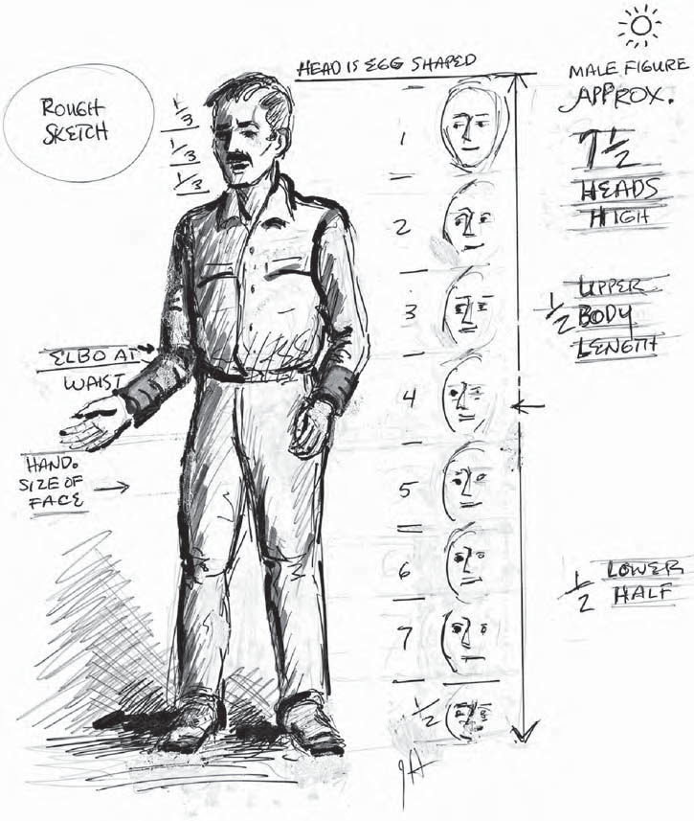

LIGHT AND SHADOW –

Where there is a light source, the object that its rays fall upon will cast a shadow. You can actually draw figures just by indicating the play of light and shade falling on and shaping them . This light and shade depiction on a figure or object will give that object its three-dimensionality.

The drawing instructor insisting that I draw the light and shade on a hat over and over again until I rendered its structure correctly. The light falling from a side window caused the side of the hat opposite the light to fall into shadow. That shadow must conform to and shape the structure of the hat, thus giving it its three-dimensionality.
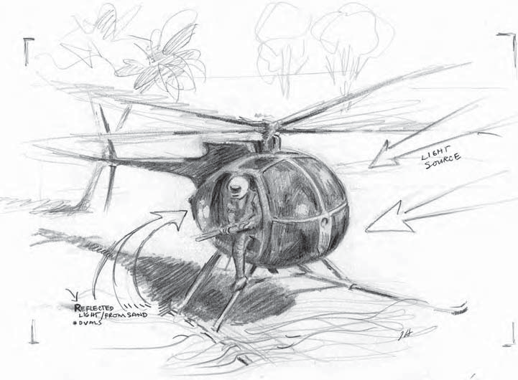

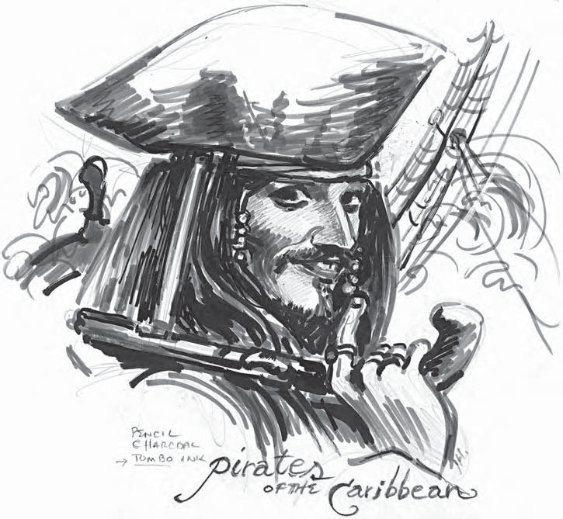

THE IMPORTANCE OF COLOR –

To change the tone or mood of a given scene, two points are to be kept in mind: comedy is light (see Figure 6-11) and tragedy is dark. We might say that melodrama can be a combination of both. That does not mean that the movie has to be shot completely in tones of gray.

The primary colors red, yellow and blue can be mixed into secondary colors. Yellow and blue make green, red and yellow are orange, and so forth. Purple (blue and red), especially when a bit of black is added, starts to lean into the darker spectrums. Red reads danger and all you have to do is watch its extensive use in films as a visual jolt for murder and mayhem. Just remember, save red for something really “hot.”
For the superb use of Technicolor, screen the 1940 The Thief of Baghdad (shown frequently on TMC)—it won an Oscar for cinematography. Watch for the shot when the evil Jaffar, in a contrasting black costume) persuades the princess to smell a
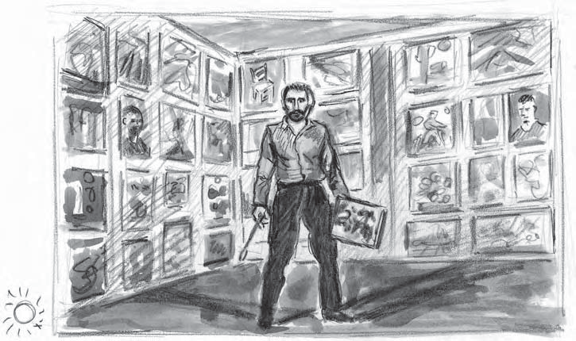
Lustrous blue rose so she will fall into a spell. In close-up, the razor sharp shot of the blue rose has maximum visual impact.

Similar to the tones in a black-and-white film, one can use monochromatic colors, which are colors, shades and color hues based on one tertiary color like a burnt umber (the right mix of orange and purple). A classic example of the subtle use of color with soft, yet luminous intensities is the Japanese masterpiece Gate of Hell (1953), which received Oscars for best foreign film and costume design. The sun- drenched colors Van Gogh used in all his paintings are brilliantly captured in Lust for Life, Vincente Minnelli’s Oscar winning 1956 film. The film, shot in and around Arles in the South of France, was nominated for Best Art Direction, Set Decoration and Color .

Black and White –
Filming in black and white is making a come back. It was used to great effect in Steven Spielberg’s Schindler’s List (1993) and more recently in Good Night and Good Luck (2005) and Sin City (2005) though the film was actually released on color stock, giving it a richer chiaroscuro effect. This popular film style, derived from the legendary detective movies like The Maltese Falcon, has been tagged film noir, which I translate as “Shoot it inexpensively at night, in and out of the black shadows.”

The common theory behind film noir is that expensive sets and lighting equipment were scarce during World War II. The films were shot in low light, making audiences less likely to notice the lack of elaborate sets and the wartime cutback on the use of electricity. We can see the influence of the film noir genre in Jean-Luc Godard’s Breathless (1960) and in the searing drama The 400 Blows (1959), Figure 6-15, by the stimulating Francois Truffaut.
Truffaut also gave us Day for Night (1973), his Oscar winning “how to make a movie” script conceit. Day for Night could have had just as much dramatic impact

if it had been shot in black and white. Truffaut was tremendously influenced by Alfred Hitchcock’s Psycho (1960), shown in Figure 6-16. Who needed color in the infa- mous shower scene? Hitchcock decided that the most realistic looking blood could be simulated best in black and white with chocolate syrup. Another example of Truffaut’s homage to Hitchcock is evident in his “dark” comedy, The Bride Wore Black, released in 1968.

Although most current films are in color, the storyboard artist can save money for the producers and give them the visceral impact they seek with storyboards executed in black and white with the added dimension of gray shadows.
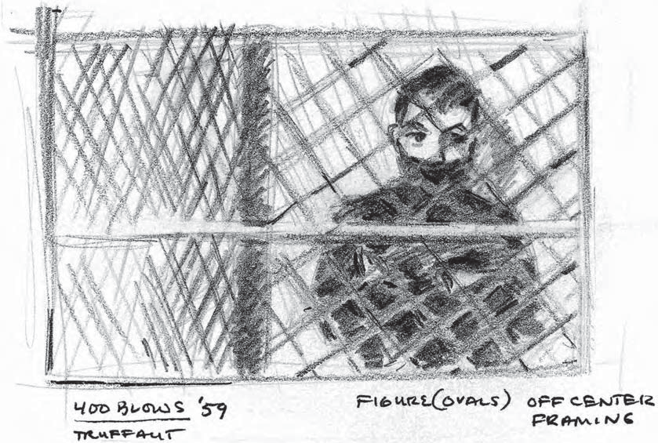

DESIGN AND COMPOSITION –

In the sketch from Tiko and the Shark (1966) in Figure 6-18, the FGD is made up of two large vertical tree limbs on which fish are being dried. The MGD has the boy moving off-center left of the frame on a horizontal limb. In the BGD to the right of the frame, you see a girl with outstretched arms. Water receding toward the horizon could be considered a fourth plane. The figures have been rendered simply, but solidly.

One of the most famous films of the 20th century is the silent film Battleship Potemkin (1925), directed by Sergei Eisenstein. Frames 76 through 84 (Figure 6-20) show us the design elements and conflict of forces at work in each dynamic shot. They have been drawn very simply but they still convey the sequence of action. In frame 85 (Figure 6-21), the mother is shot and starts to fall. It has been rendered in full dimensional light and shade. With practice, patience and persistence, you will soon be able to make the transition from simple figures to fully dimensional renderings.
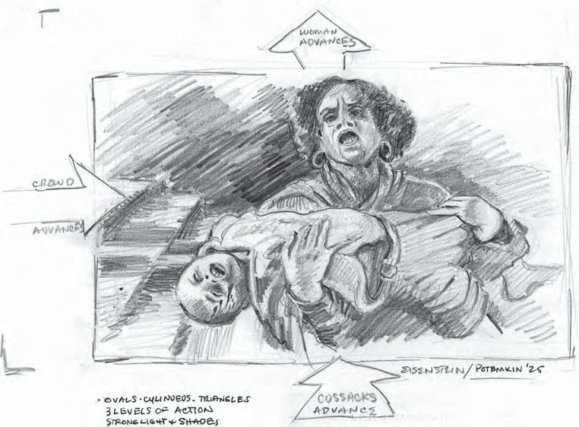
If I were to recommend one book that is a compendium of the best of Hollywood’s films, it is Ronald Haver’s David O. Selznick’s Hollywood (1987). It’s full of high quality films from this prolific producer. Selznick reached his peak with the spectacu- lar Gone with the Wind (1939, directed by Victor Fleming) and, in contrast, the rich black-and-white cinematography of Rebecca (1940, directed by Alfred Hitchcock). You will find at least 1,500 illustrations from preproduction conferences involving storyboarding, set design, costume design and set decoration, all the way up to the actual production scheduling involving many original shots and camera setups (see Figure 6-22). This volume alone gives you insight into the multiple areas of visual enhancement that make for breathtaking films.

CHAPTER – VIII
EXAMPLE OF
STORY BOARD
(OWN)
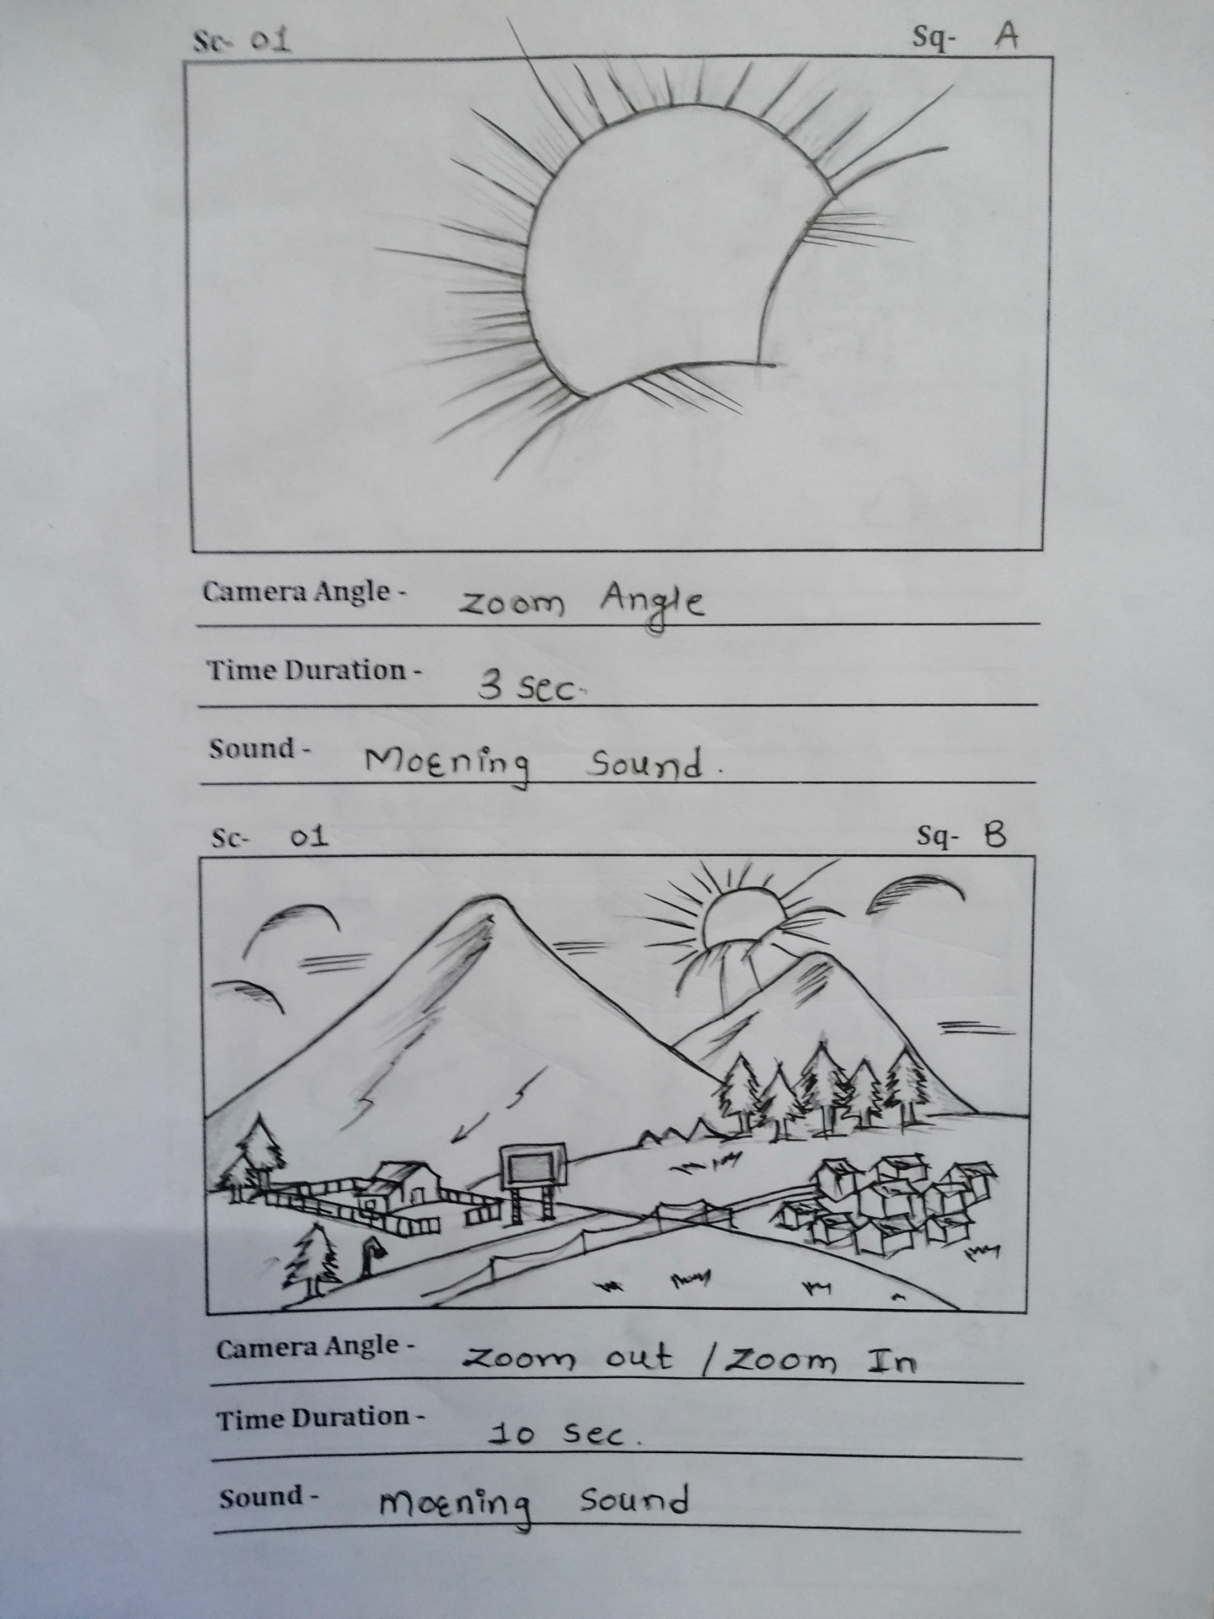
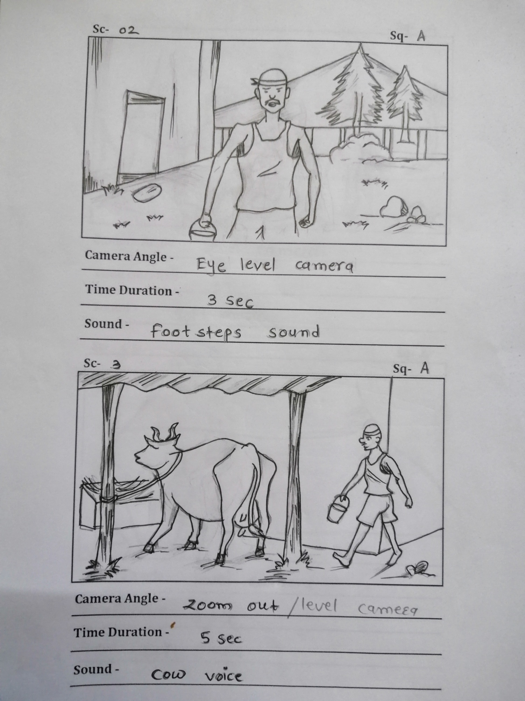
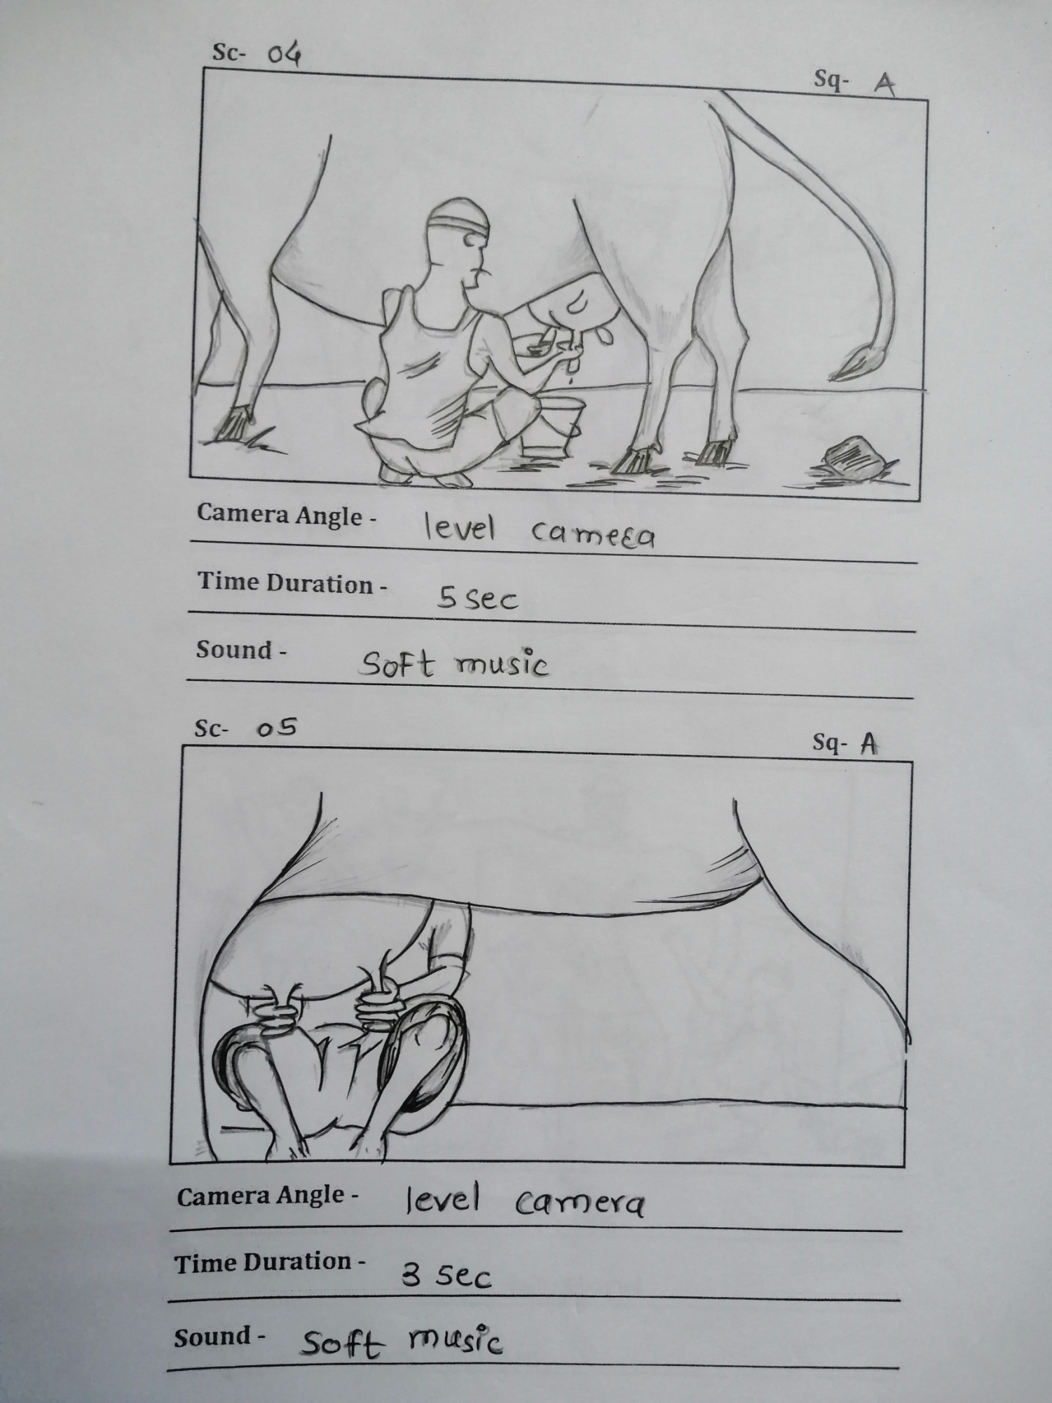
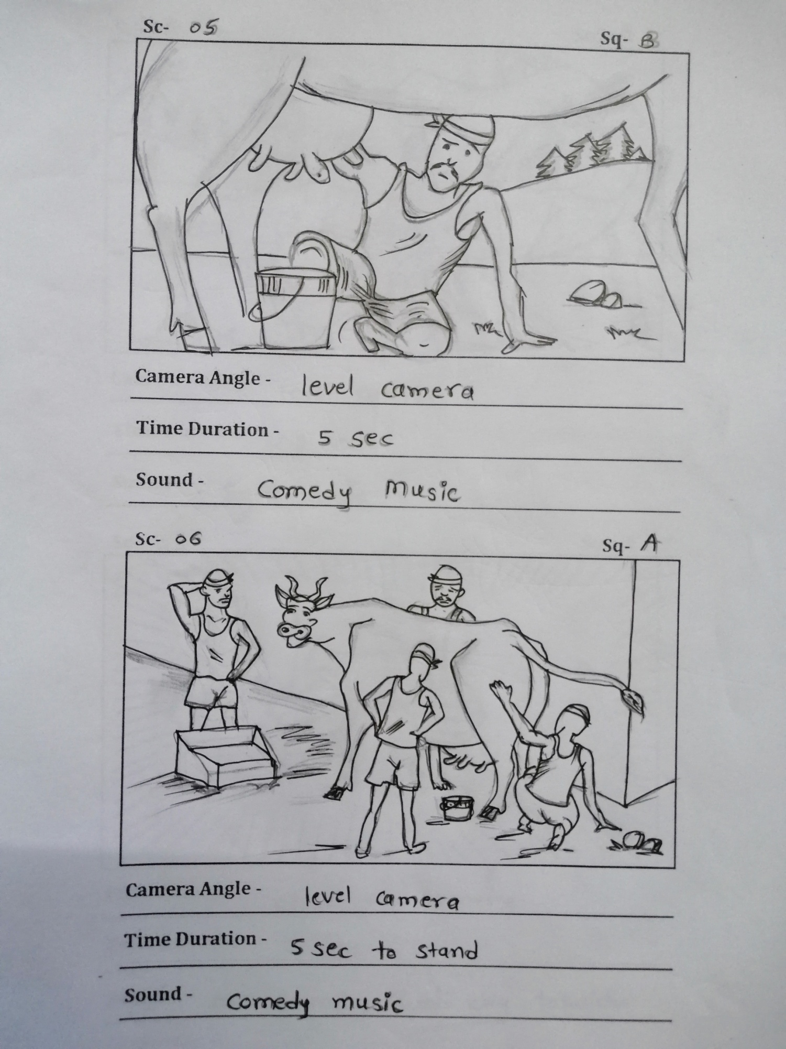
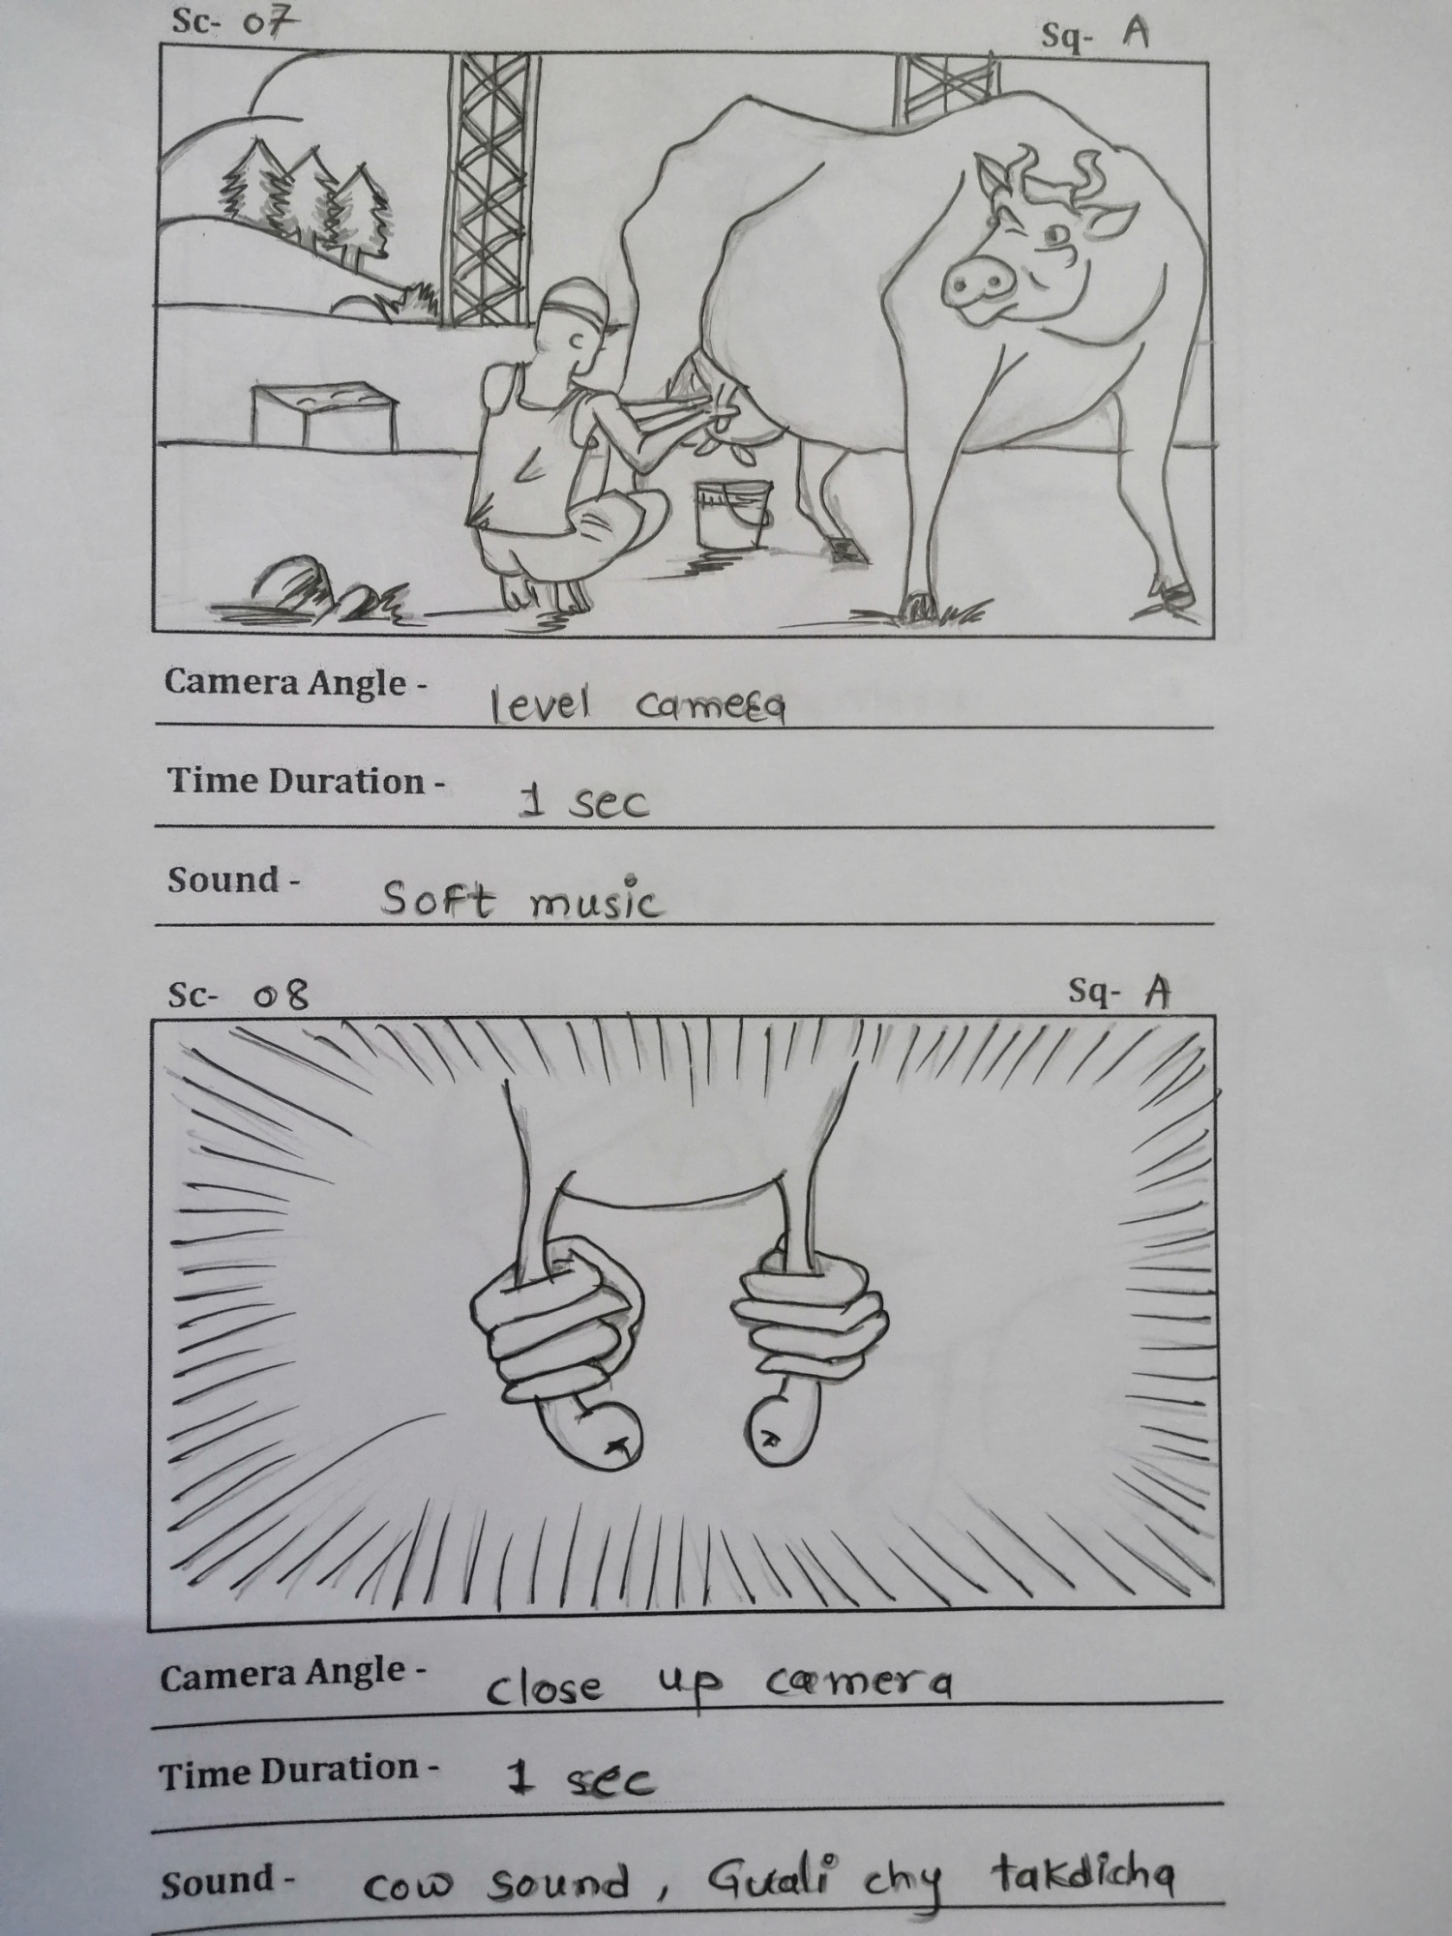
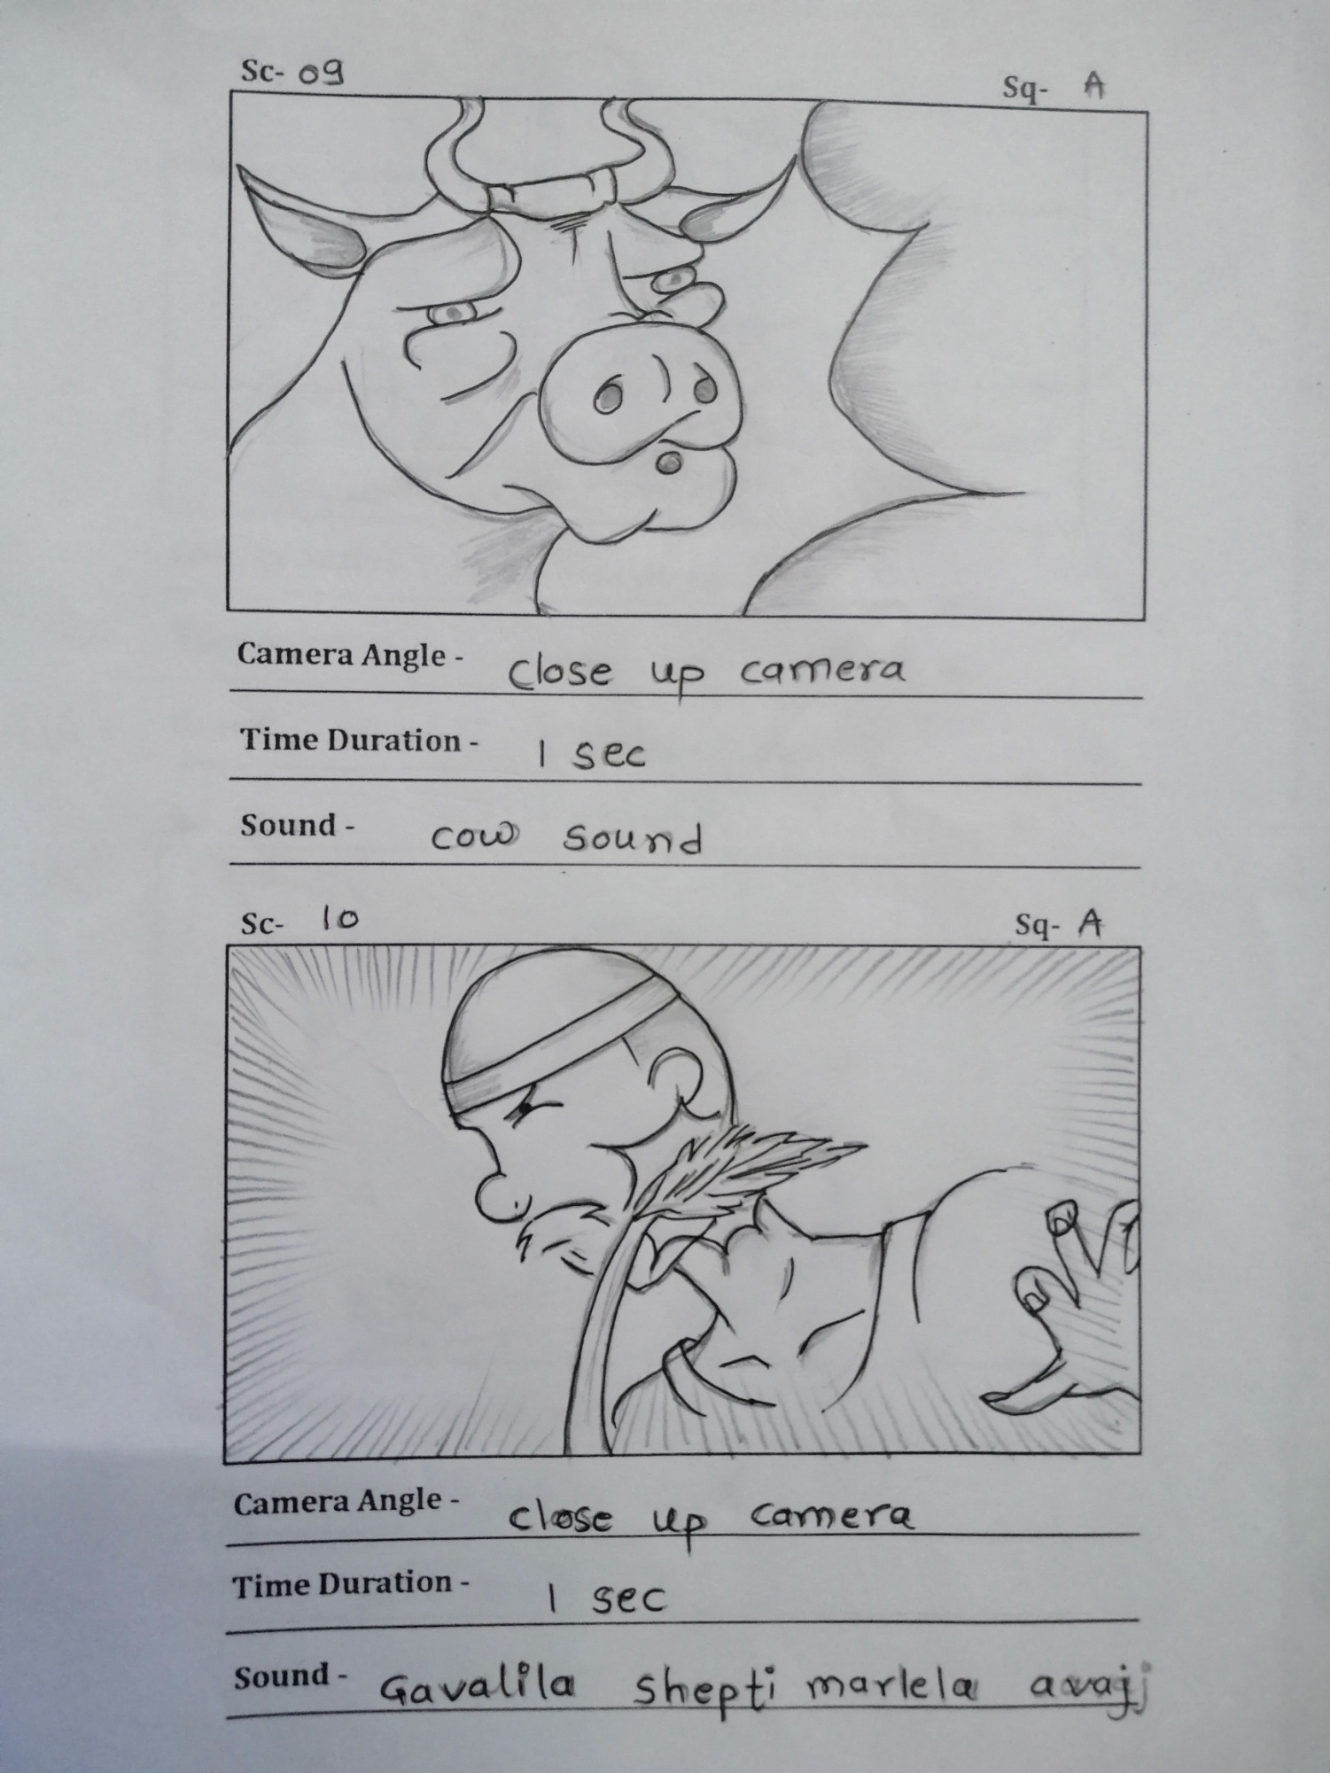
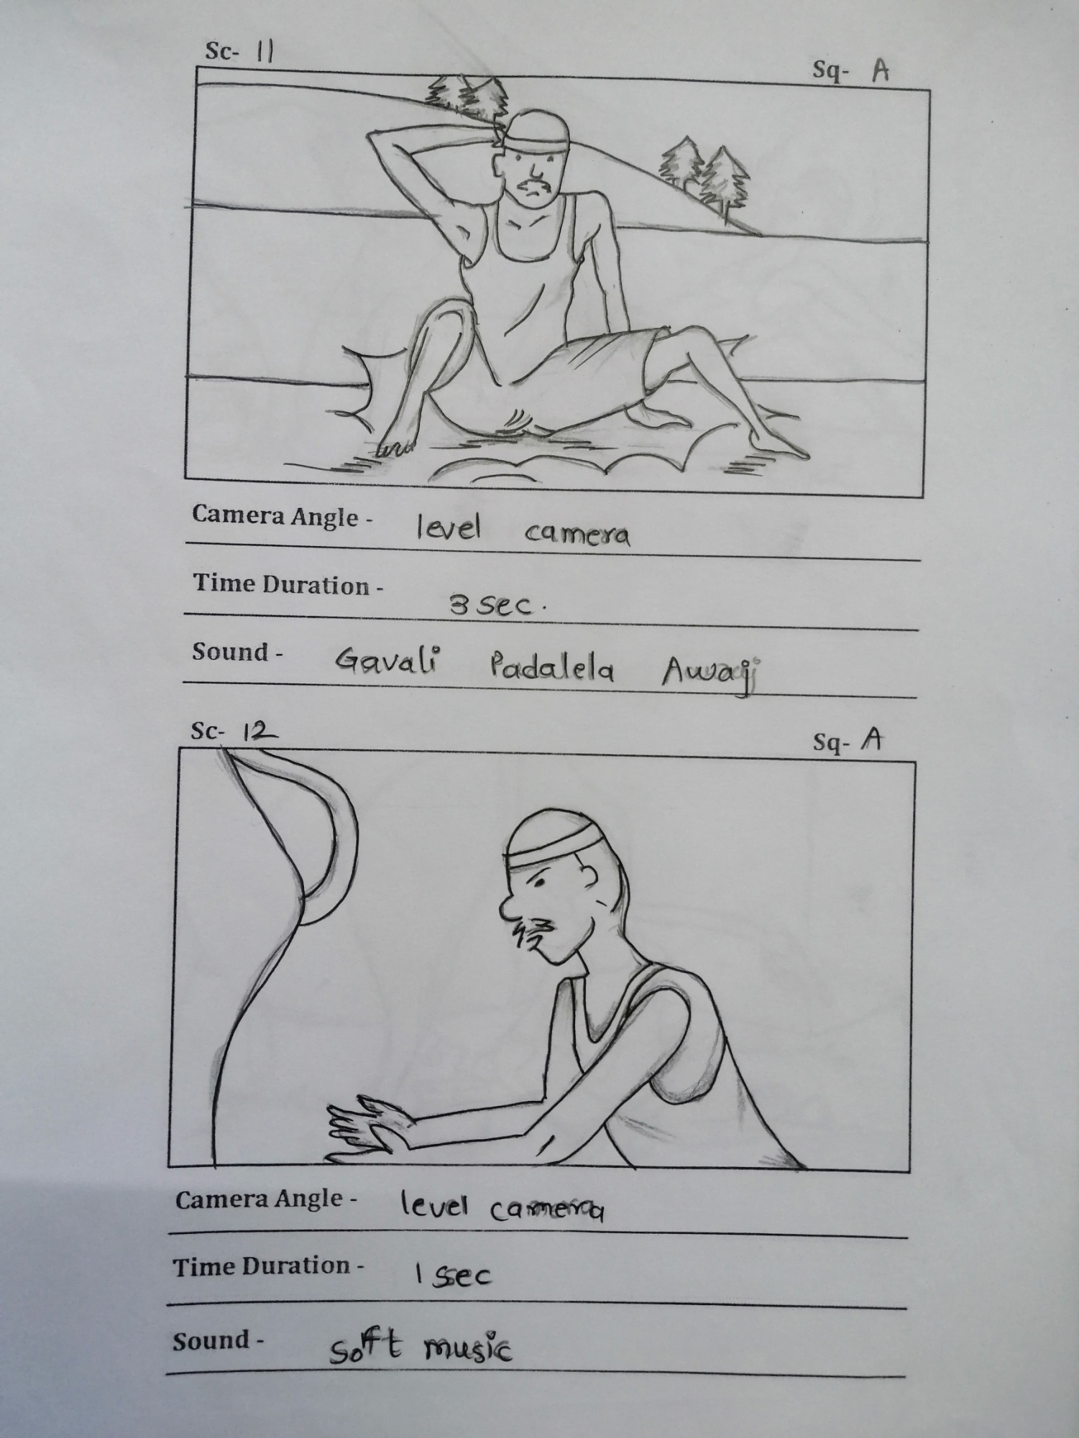
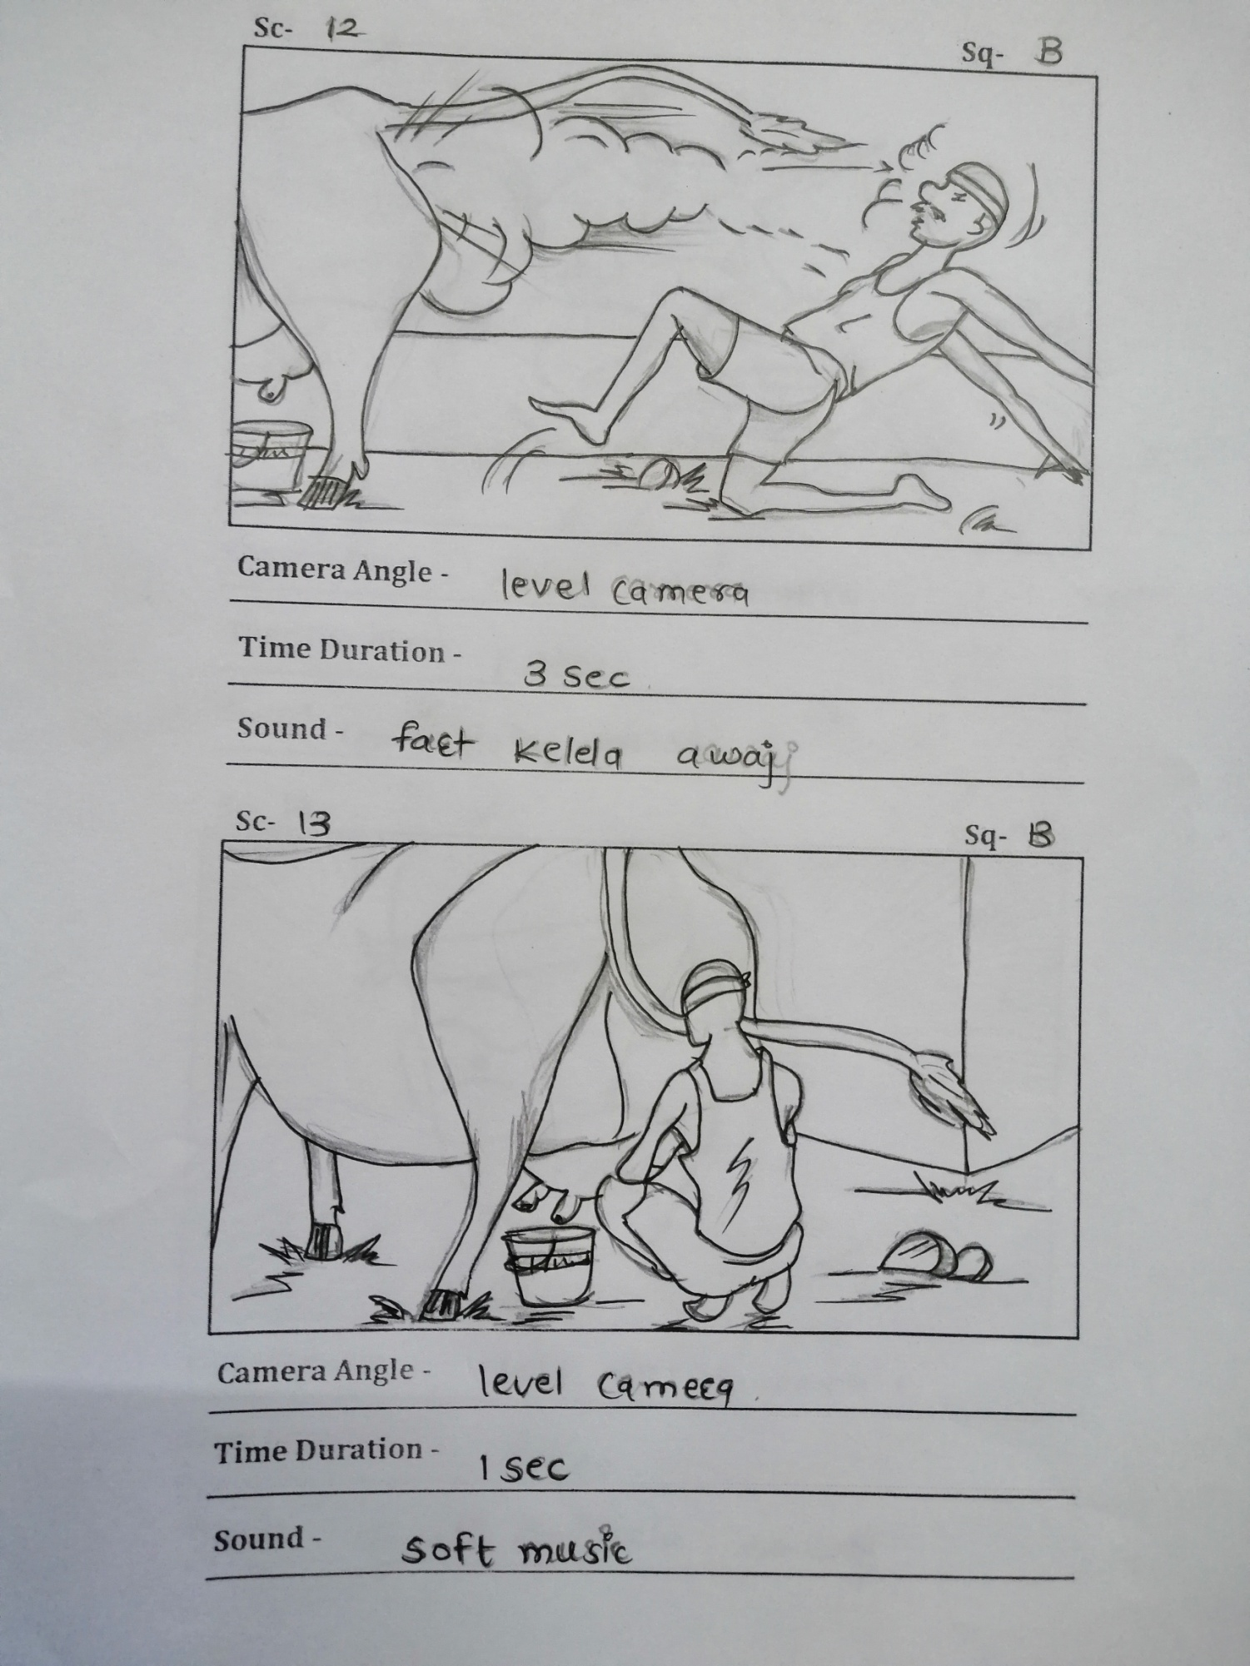
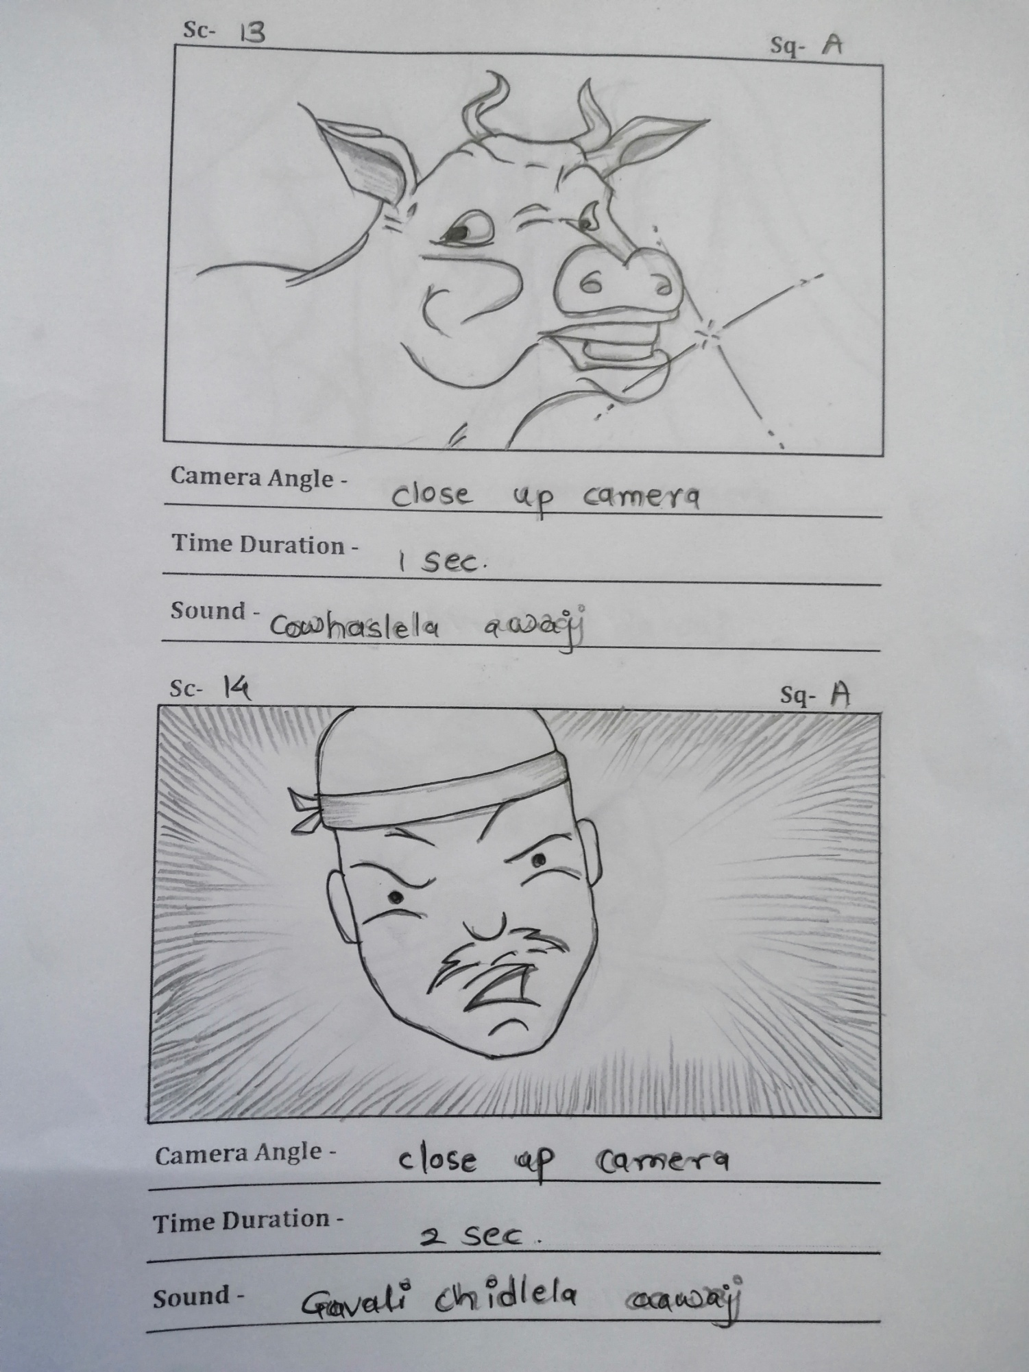
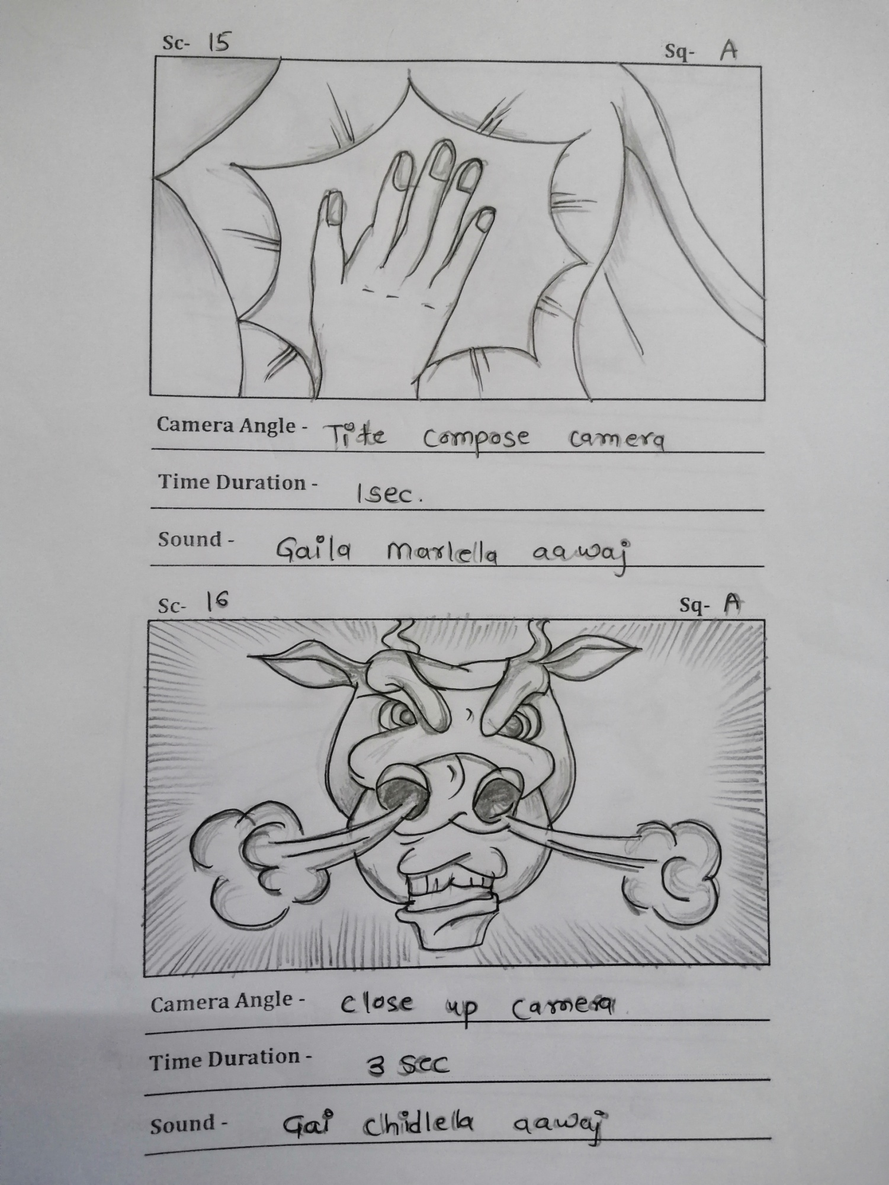
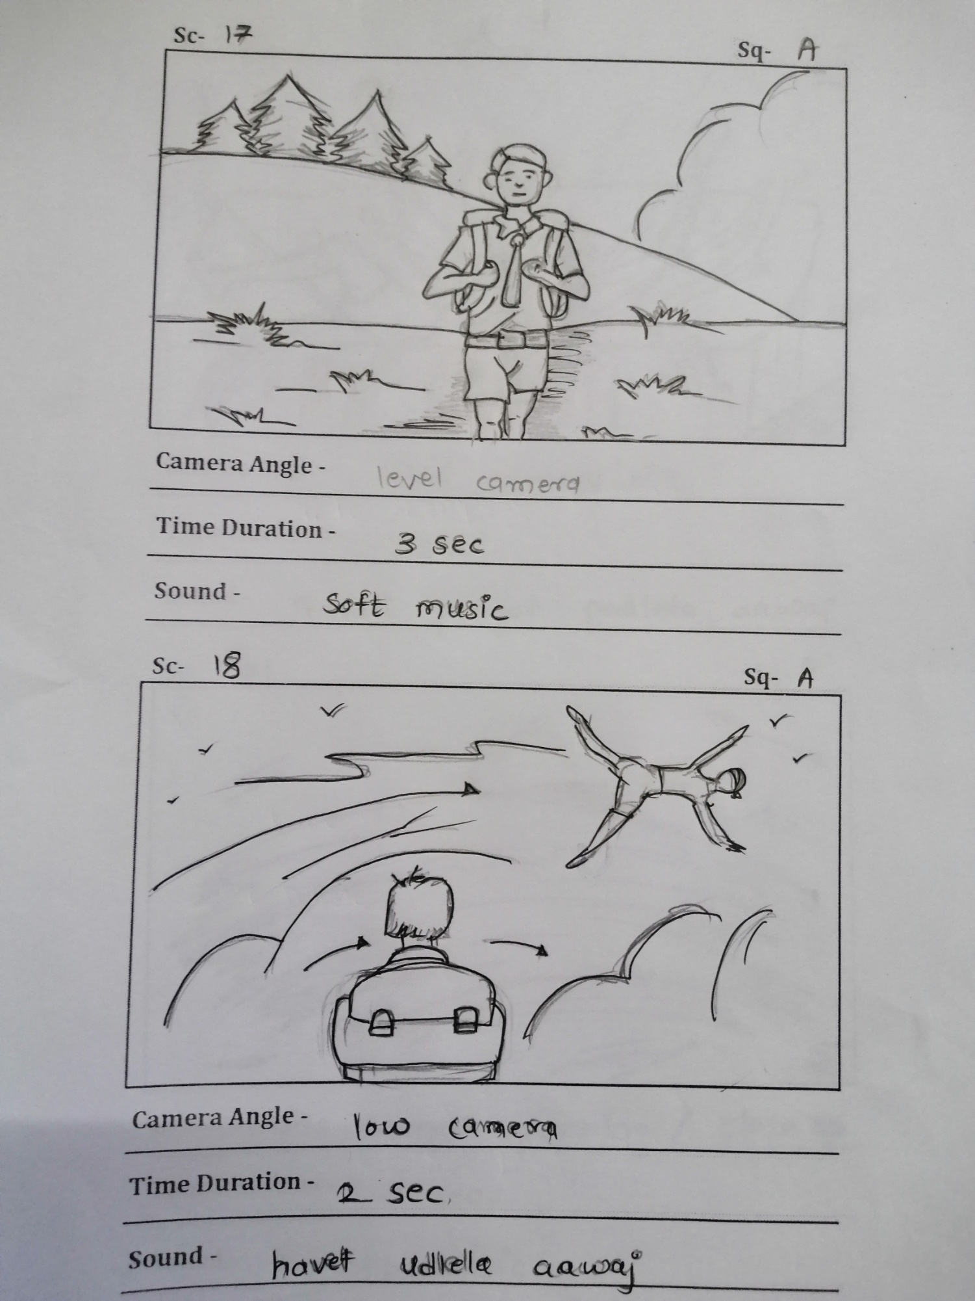
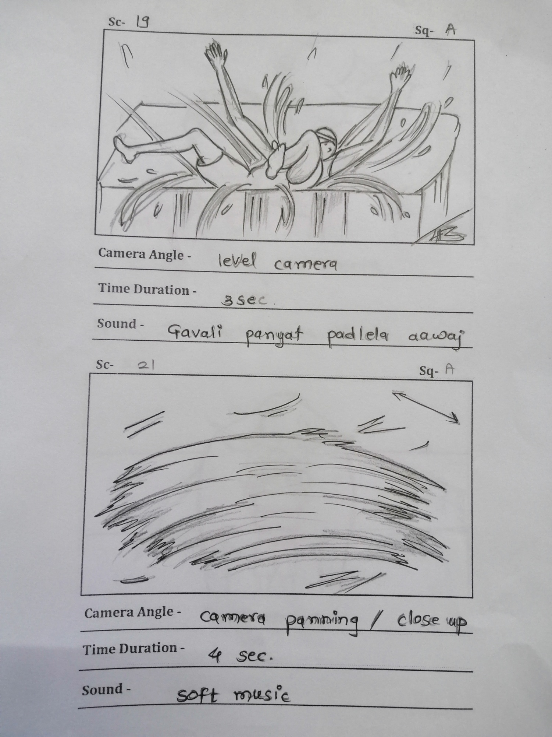
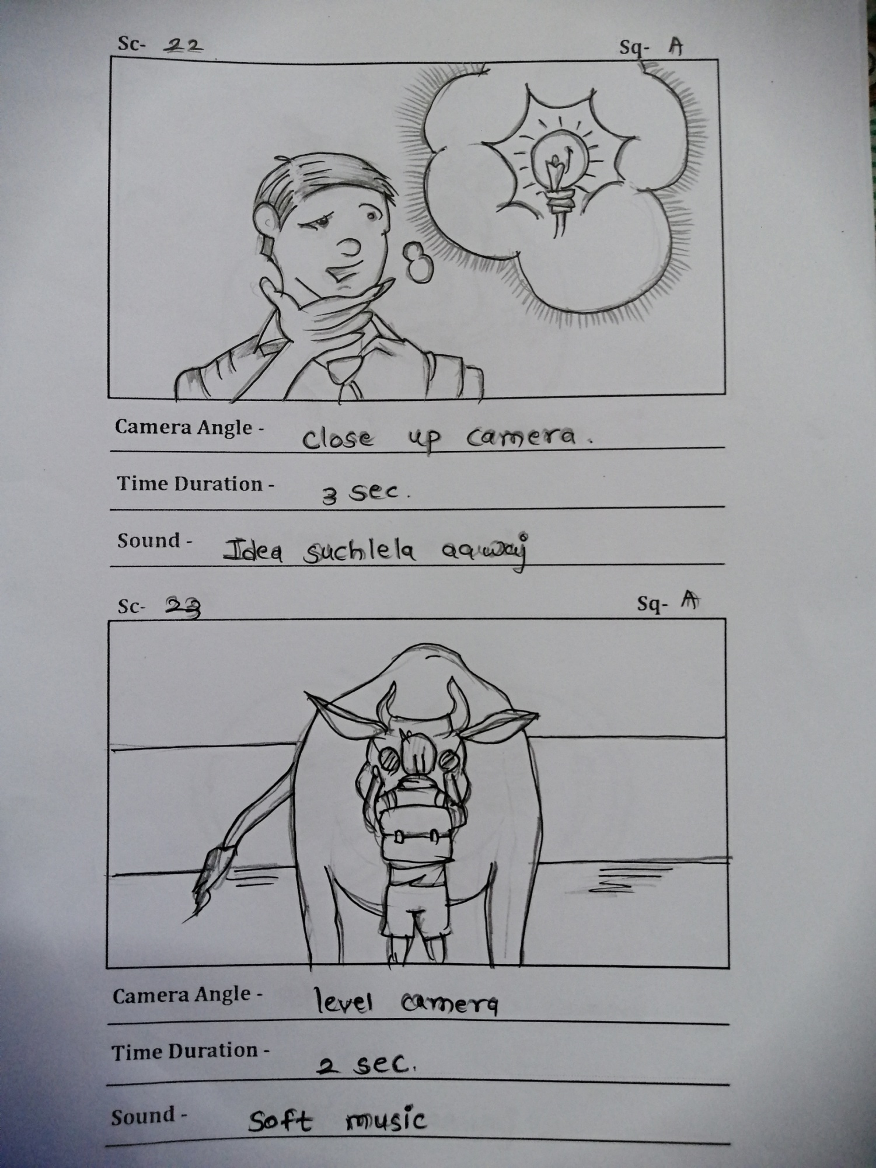
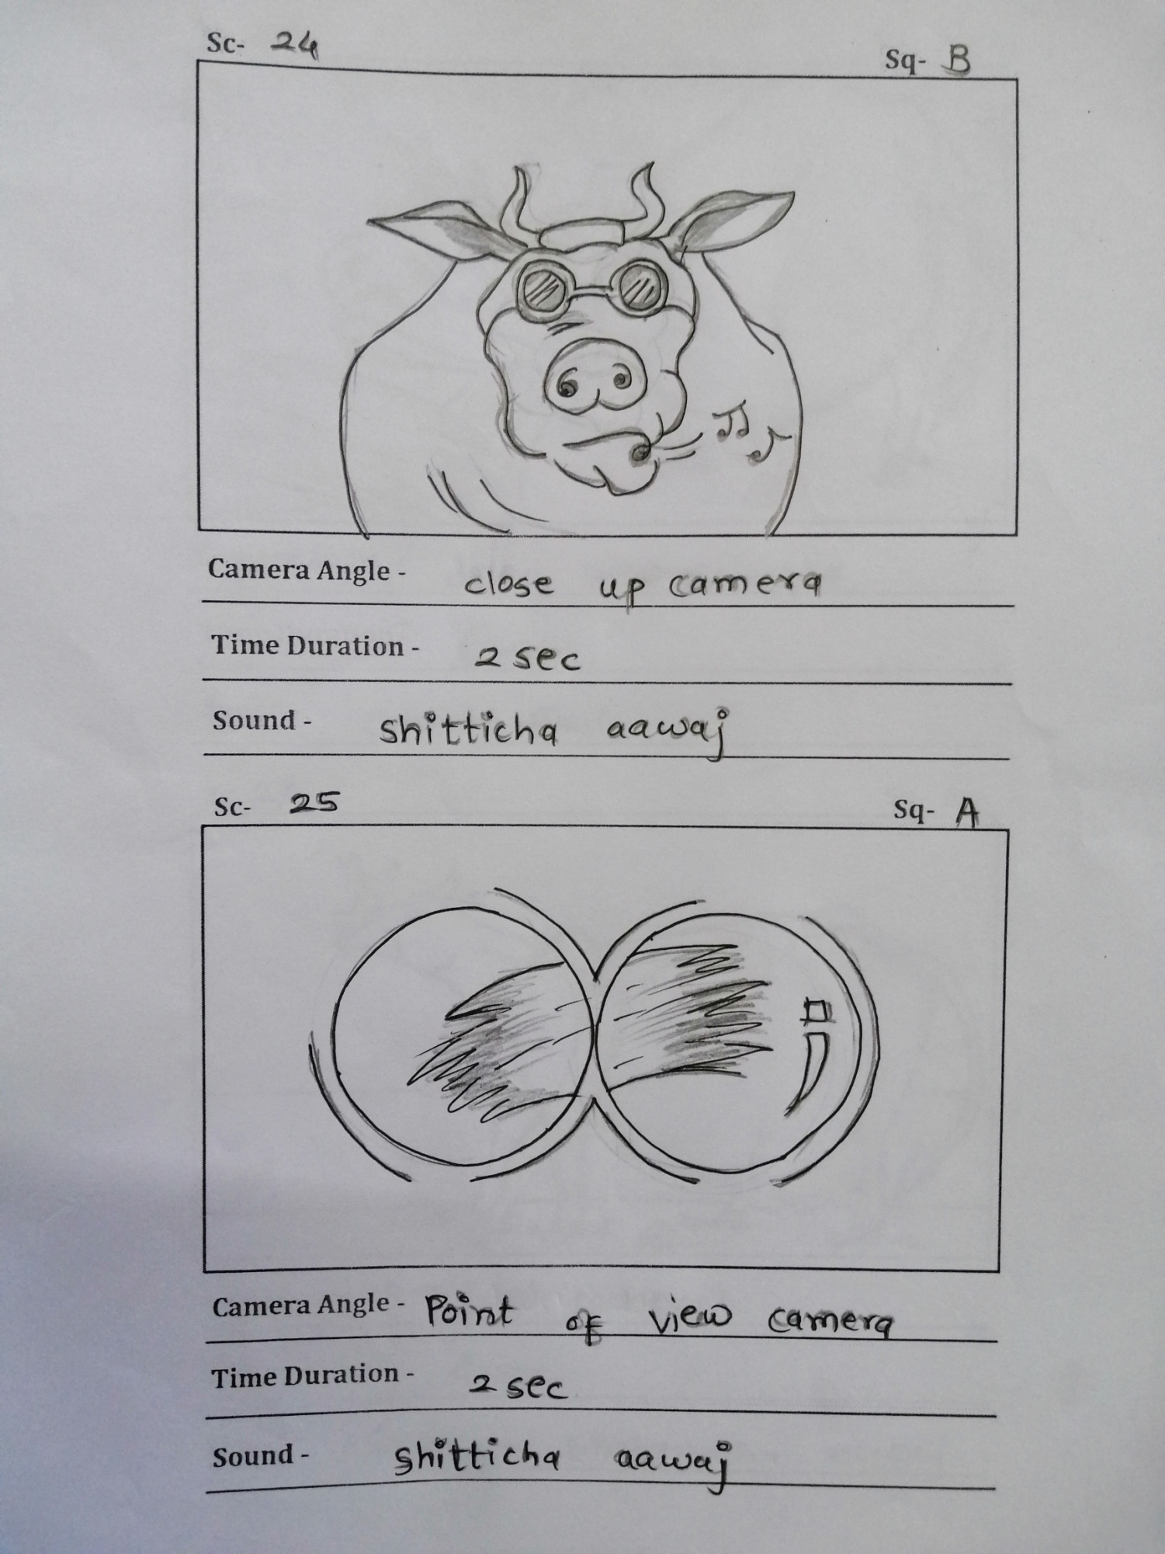
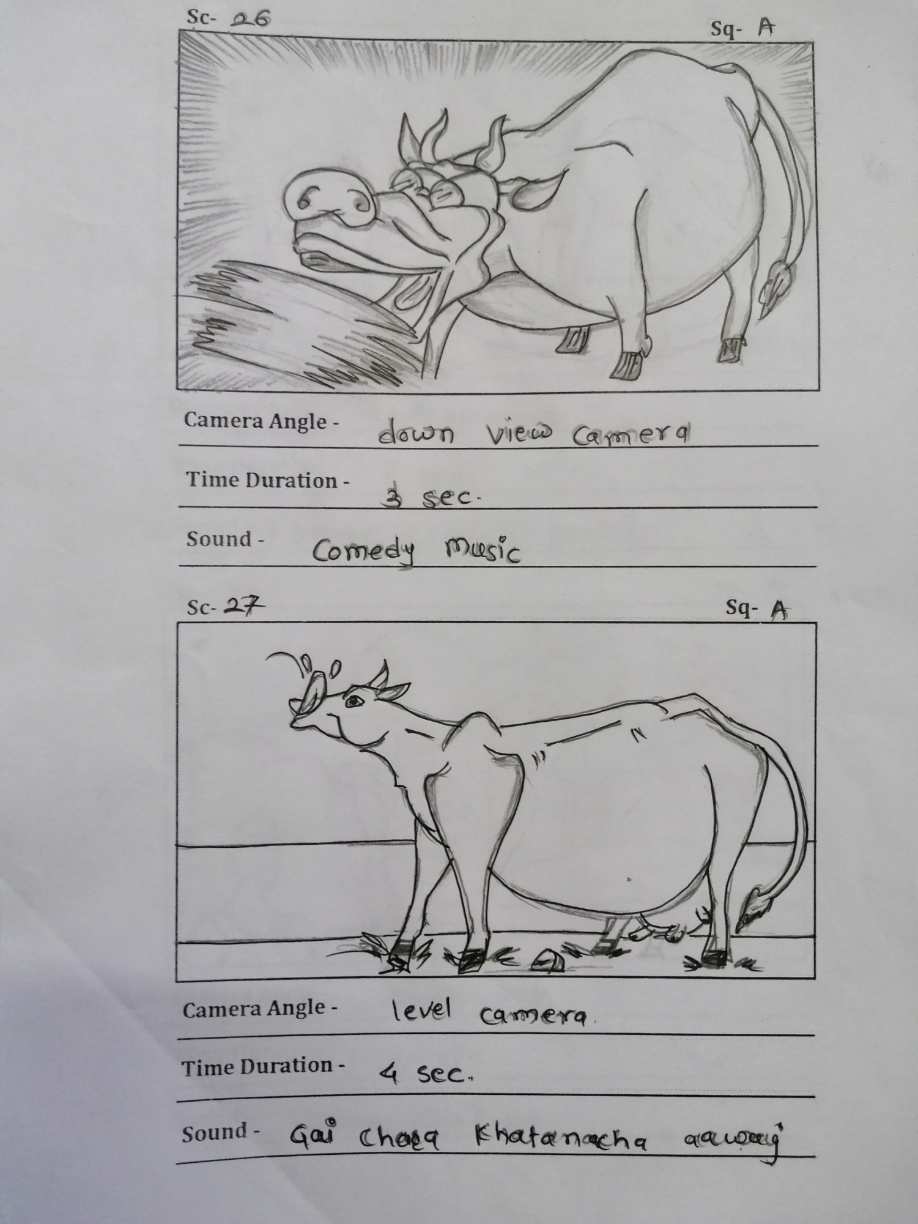
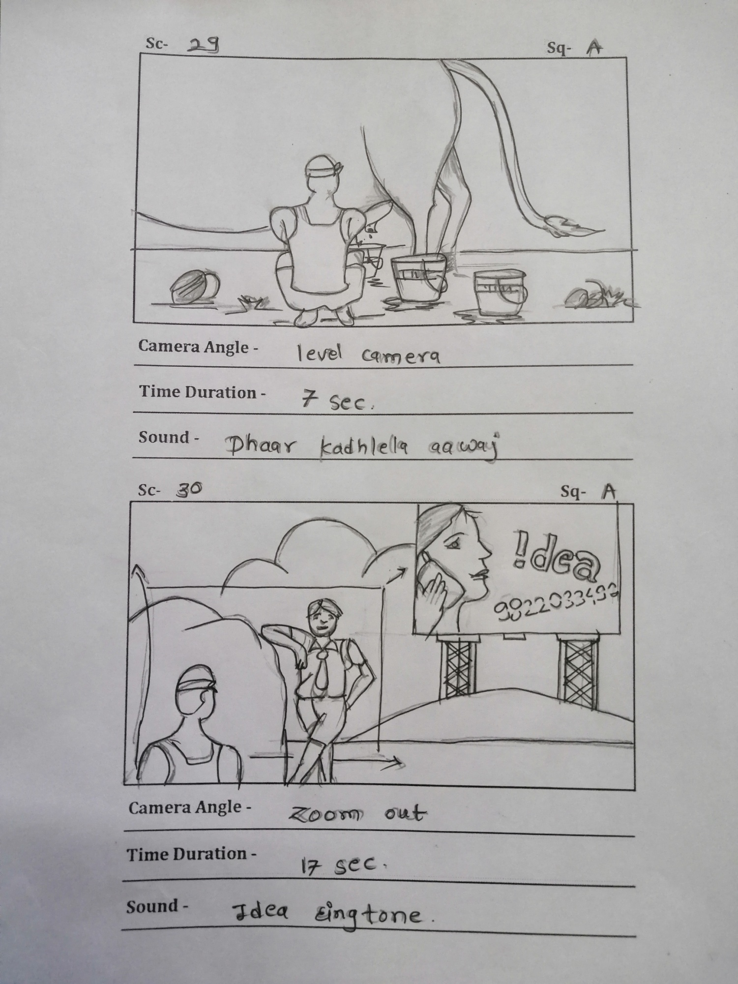

CHAPTER – IX
CONCLUSION

CONCLUSION –
The understanding of storyboarding as a process tool in pre-brief activities supporting innovation management is new and knowledge have been developed regarding the use and characteristics of storyboarding in comparison to the traditional way of working in this phase, writing documents. The pre-brief activities in innovation processes are a topic hidden in “the fuzzy front end”. Since these activities traditionally are developed using written documents the comparison brings knowledge about hidden issues when executed in a traditional way. A brief developed writing document contains hidden fixations. The academic contribution also consists of the bridge between designerly thinking and design thinking. Where enhanced knowledge regarding design thinking at the company IDEO are explained through the reflective practice (Schön, 1991). This bridge enables scholars in the discourse of designerly thinking to reflect and discuss the discourse of design thinking as part of the designerly thinking discourse and in this way contribute in both discourses. The need for innovation management to understand the reflective practice as part of the early phases of innovation processes has been shown. By providing a model of the reflective practice a discussion about the process and outcomes of each step can be achieved between design teams and innovation manage.
One such area is something that has been observed during the experiments comparing storyboarding and written documents. There seems to be much more interaction in the teams that work with storyboarding than in the teams working with written briefs. It is not only the fact that all team members seem to be involved in the interaction; the level of interaction and playfulness seems to be higher. This could easily be analyzed since all of these experiments were filmed; what is needed is time to analyses the material. Another part that is really interesting is the ambiguity of storyboarding, which is mentioned in the discussion as a space for reframing. The fact that storyboarding could bring space for reframing in the pre-brief activities could bring new knowledge both to storyboarding and to the activities involved in making a brief today. The setup of this kind of research could be done using experiments with teams of managers and designers using storyboarding in an area of interest in order to create a brief.

CHAPTER – X
REFERENCES

- THE ART OF THE STORYBOARD
2..Library of Congress Cataloging-in-Publication Data
Application submitted

- British Library Cataloguing-in-Publication Data
A catalogue record for this book is available
- Specshoward.edu

