COLLEGE OF NON-CONVENTIONAL VOCATIONAL COURSES FOR WOMEN
(CNCVCW), CSIBER.
KOLHAPUR

A PROJECT REPORT ON
Graphic Design
SUBMITED TO
CNCVCW AFFLIATED TO
SHIVAJI UNIVERSITY KOLHAPUR
IN PARTIAL FULFILLMENT OF REQUIREMENT FOR THE DEGREE OF
BACHELOR OF MULTIMEDIA
SUBMITTED BY
SARITA D. BADE
UNDER THE GUIDANCE OF
MR. Raghunath Topkar
ASSISTAN PROFESSOR
DEPARTMENT OF MULTIMEDIA
2020-2021
DECLARATION

I hereby declare that, the project work entitled Graphic Design is my original work. To the best of My knowledge and belief it contains no material previously published either Written by another person or material which to a substantial extent has been Accepted for the award of any other degree or diploma of the university Other institute of higher learning. Except where due to acknowledge Has been made in the text.

NAME: SARITA DEEPAK BADE
ROLL NO: 2
SIGNATURE:
DATE:

COLLEGE OF NON-CONVENTIONAL VOCATIONAL COURSES FOR
WOMEN
(CNCVCW)
CSIBER, KOLHAPUR.
CERTIFICATE
This is to certify that, SARITA DEEPAK BADE of Bachelor of Multimedia (B.M.M.) IV has satisfactory completed the project entit “Graphic Design” in partial Fulfillment of Bachelor Degree in Multimedia affiliated to Shivaji University, Kolhapur, for the academic year 2020-2021.

Raghunath Topkar
(Project Guide)
Forwarded Through: Dr. A. R. Kulkarni
(M. Sc., PhD, MMEI, RQP, LEAD AUDITOR (EMS))

(Principal )

ACKNOWLEDGMENT

I have great pleasure in the submission of this project entitled “GRAPHIC DESIGN” in partial fulfillment of bachelors of Multimedia (B. M. M) program.
While submitting this project, I take this opportunity to think those directly and indirectly related to project work. Without their active co-operation and guidance, it would have extremely difficult to complete this in time.
As the outset, I keep in record my deep sense of gratitude towards my project guide MR. RAGUNATH TOPKAR who guided me, right form initial stage of project and offered me several valuable suggestion for developing this project in a systematic and presentable manner.
I am also thankful to our faculty members, Dr.A.R.Kulkarni, for their support throughout support throughout my project work.

DATE:
PCACV: CNCVCW, KOLHAPUR
Sarita Deepak Bade

INDEX
Chapter no. | Title
1 | History of graphic design
2 | Graphic design definition
3 | Product design.
4 | Branding design.
5 | Website design
6 | Print design
8 | Environmental design
9 | Animation design

- History of graphic design

Graphic design proper really began after the invention of the printing press in 1440, but the roots of visual communication stretch all the way back to caveman times. In this section, we'll run down the events of early history that paved the way for graphic design centuries before the world was ready for it.
The role of the graphic designer in the communication process is that of encoder or interpreter of the message. They work on the interpretation, ordering, and presentation of visual messages. The design work always starts from a client's demand, a demand that ends up being established linguistically, either orally or in writing, that is, that graphic design transforms a linguistic message into a graphic manifestation.^{[2]}
Graphic design has, as a field of application, different areas of knowledge focused on any visual communication system. For example, it can be applied in advertising strategies, or it can also be applied in the aviation world.^{[3]} In this sense, in some countries graphic design is related as only associated with the production of sketches and drawings, this is incorrect, since visual communication is a small part of a huge range of types and classes where it can be applied.
Given the rapid and massive growth in information sharing, the demand for experienced designers is greater than ever, particularly because of the development of new technologies and the need to pay attention to human factors beyond the competence of the engineers who develop them.

- Graphic design definition

Graphic design is the profession and academic discipline whose activity consists in projecting visual communications intended to transmit specific messages to social groups, with specific objectives.
Graphic design is the profession and academic discipline whose activity consists in projecting visual communications intended to transmit specific messages to social groups, with specific objectives. Therefore, it is an interdisciplinary branch of design whose foundations and objectives revolve around the definition of problems and the determination of objectives for decision-making, through creativity, innovation and lateral thinking along with digital tools, transforming them for proper interpretation. This activity helps in the optimization of graphic communications (see also communication design). It is also known as visual communication design, visual design or editorial design.

- Product design
Product design as a verb is to create a new product to be sold by a business to its customers. A very broad coefficient and effective generation and development of ideas through a process that leads to new products. Thus, it is a major aspect of new product development. Product design process: the set of strategic and tactical activities, from idea generation commercialization used to create a product design. 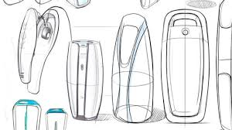

In a systematic approach, product designers conceptualize and evaluate ideas, turning them into tangible inventions and products. The product designer's role is to combine art, science, and technology to create new products that people can use. Their evolving role has been facilitated by digital tools that now allow designers to do things that include communicate, visualize, analyze, 3D modeling and actually produce tangible ideas in a way that would have taken greater human resources in the past. Product design is sometimes confused with (and certainly overlaps with) industrial design, and has recently become a broad term inclusive of service, software, and physical product design. Industrial design is concerned with bringing artistic form and usability, usually associated with craft design and ergonomics, together in order to mass-produce goods. Other aspects of product design and industrial design include engineering design, particularly when matters of functionality or utility (e.g. problem-solving) are at issue, though such boundaries are not always clear.

- Branding design
Branding design describes how a brand chooses to visually represent their brand identity to the public. When talking about branding design, it typically refers to key brand elements such as the logo, color scheme, typography, and other design components that makes a brand stand out from competitors, and recognizable to consumers.
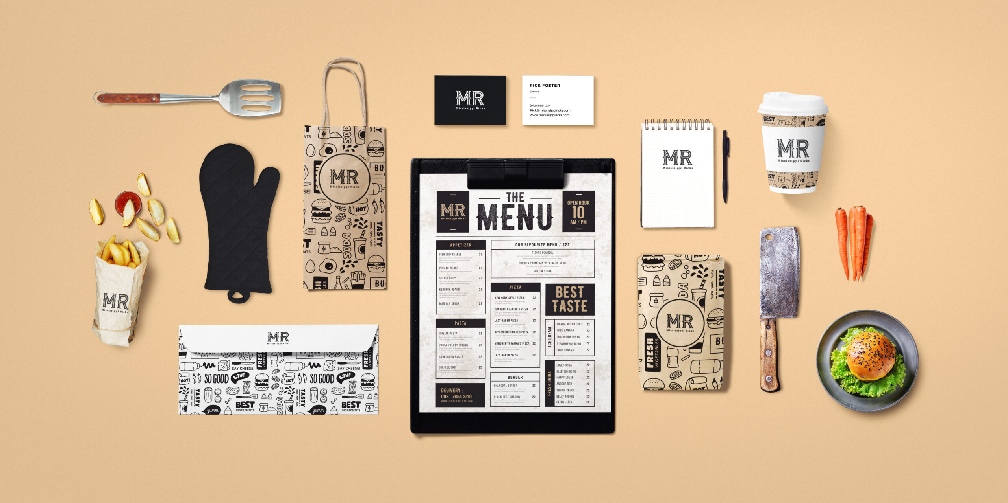Besides these main elements of brand identity design, branding design also more broadly refers to how a brand chooses to express themselves in both the physical and digital world; whether that’s on social media, in physical stores, or even the interior design of company office spaces. It’s becoming increasingly important for companies to ensure their brand design is conveyed consistently across all these touchpoints—often by using brand guidelines—in order to strengthen their brand image in the minds of their audience, helping to leave a lasting impression and cement emotional connections with the brand. With the digital space being more crowded than ever with many brands having increasingly similar products from one competitor to the next, branding design can be a key differentiator in helping a brand stand out and resonate with target audiences. A brand’s design should ideally represent the personality of a brand, its values, and it can be a powerful tool in shaping consumer attitudes about your brand. Sometimes, a memorable logo or catchy color scheme can leave a longer-lasting impression on consumers than any big-budget ad campaign.
- Website design
Web design encompasses many different skills and disciplines in the production and maintenance of websites. The different areas of web design include web graphic design; user interface design (UI design); authoring, including standardised code and proprietary software; user experience design (UX design); and search engine optimization.
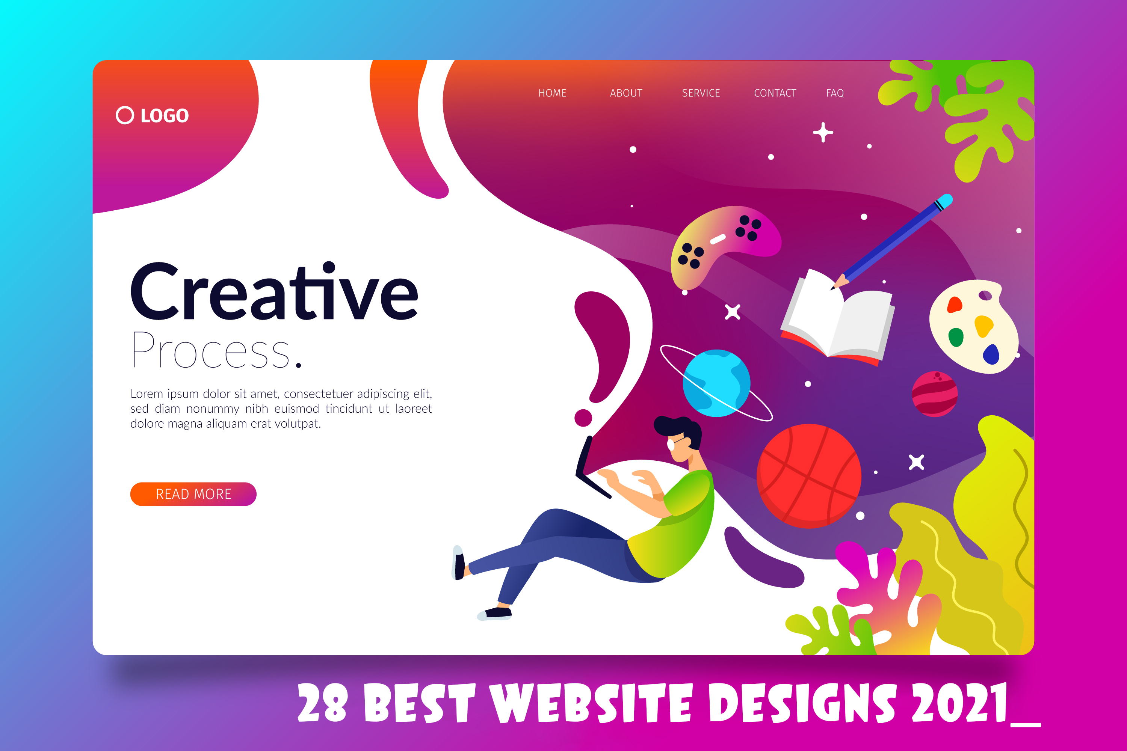
Often many individuals will work in teams covering different aspects of the design process, although some designers will cover them all. The term "web design" is normally used to describe the design process relating to the front-end (client side) design of a website including writing markup. Web design partially overlaps web engineering in the broader scope of web development. Web designers are expected to have an awareness of usability and if their role involves creating markup then they are also expected to be up to date with web accessibility guidelines.
Although web design has a fairly recent history. It can be linked to other areas such as graphic design, user experience, and multimedia arts, but is more aptly seen from a technological standpoint. It has become a large part of people's everyday lives. It is hard to imagine the Internet without animated graphics, different styles of typography, background, videos and music.

Print design
Print design, a subset of graphic design, is a form of visual communication used to convey information to an audience through intentional aesthetic design printed on a tangible surface, designed to be printed on paper, as opposed to presented on a digital platform. A design can be considered print design if its final form was created through an imprint made by the impact of a stamp, seal, or dye on the surface of the paper. 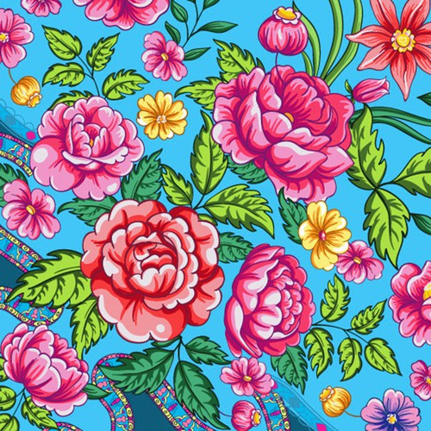

There are several methods used to create print design artworks, spanning more than five hundred years. Printing technologies available throughout history heavily influenced the style of designs created by graphic designers at the time of production, as different methods of creating print design offer varying features. Before the emergence of the design and printing technologies of the twentieth and twenty-first century such as the inkjet printer, Adobe Illustrator, Adobe Photoshop, and Adobe InDesign, print design relied on mechanical technologies such as the letterpress and lithography.

- Environmental design

Environmental design is the process of addressing surrounding environmental parameters when devising plans, programs, policies, buildings, or products. It seeks to create spaces that will enhance the natural, social, cultural and physical environment of particular areas.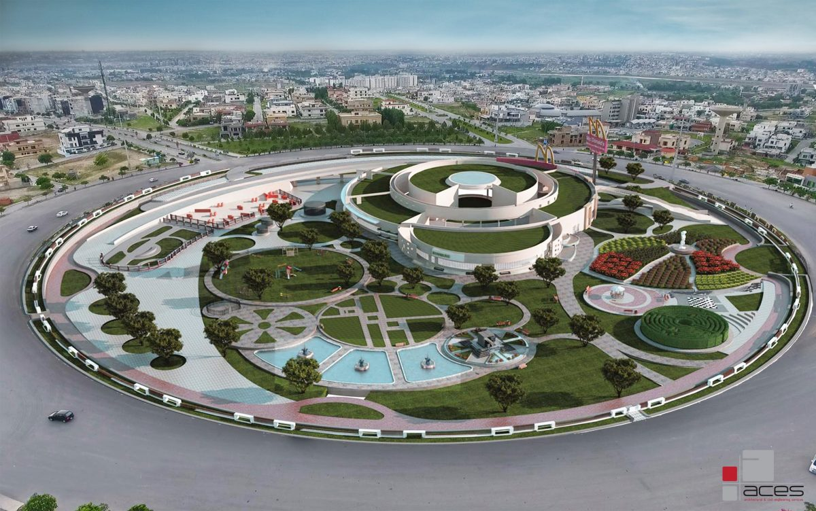 Classical prudent design may have always considered environmental factors; however, the environmental movement beginning in the 1940s has made the concept more explicit. Environmental design can also refer to the applied arts and sciences dealing with creating the human-designed environment. These fields include architecture, geography, urban planning, landscape architecture, and interior design. Environmental design can also encompass interdisciplinary areas such as historical preservation and lighting design. In terms of a larger scope, environmental design has implications for the industrial design of products: innovative automobiles, wind power generators, solar-powered equipment, and other kinds of equipment could serve as examples. Currently, the term has expanded to apply to ecological and sustainability issues.

- Animation design

Animation is a method in which figures are manipulated to appear as moving images. In traditional animation, images are drawn or painted by hand on transparent celluloid sheets to be photographed and exhibited on film. Today, most animations are made with computer-generated imagery (CGI). Computer animation can be very detailed 3D animation, while 2D computer animation (which may have the look of traditional animation) can be used for stylistic reasons, low bandwidth, or faster real-time renderings.
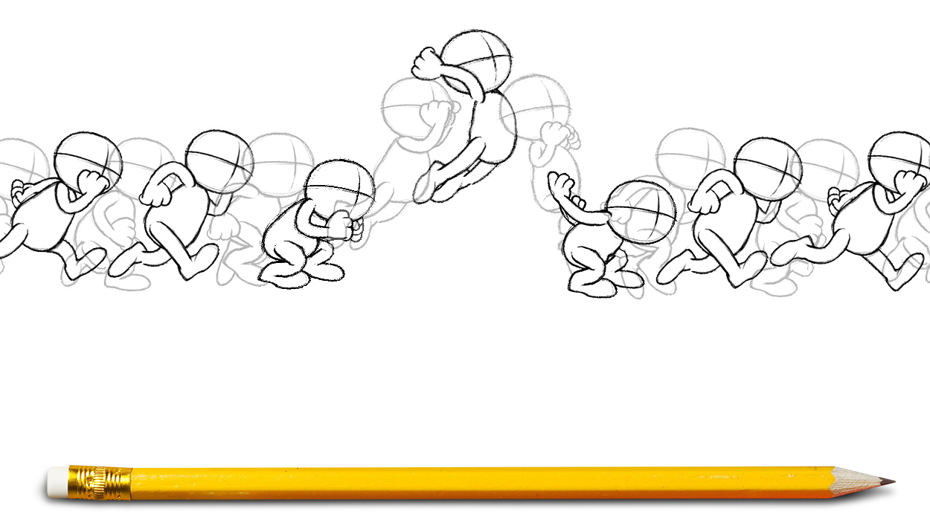 Other common animation methods apply a stop motion technique to two and three-dimensional objects like paper cutouts, puppets, or clay figures. Commonly, the effect of the animation is achieved by a rapid succession of sequential images that minimally differ from each other. The illusion—as in motion pictures in general—is thought to rely on the phi phenomenon and beta movement, but the exact causes are still uncertain. Analog mechanical animation media that rely on the rapid display of sequential images include the phénakisticope, zoetrope, flip book, praxinoscope, and film. Television and video are popular electronic animation media that originally were analog and now operate digitally. For display on the computer, techniques like animated GIF and Flash animation were developed. Animation is more pervasive than many people know. Apart from short films, feature films, television series, animated GIFs, and other media dedicated to the display of moving images, animation is also prevalent in video games, motion graphics, user interfaces, and visual effects.
The physical movement of image parts through simple mechanics—for instance moving images in magic lantern shows—can also be considered animation. The mechanical manipulation of three-dimensional puppets and objects to emulate living beings has a very long history in automata. Electronic automata were popularized by Disney as animatronics.

